# System Testing

## Test Plan

### Introduction

I will complete the integration testing before I test the system’s functionality. The three units tested are the ‘Main Menu’ Unit, the ‘Practice’ Unit and the ‘User Model’ Unit.

My system testing will have to check normal, boundary and erroneous data entries. I have created a Test Plan which will test the functionality of the models, as well as various user inputs. I felt that the most important thing to test was that the models are always restricted to an M1 style problem, as there are many validation checks associated with this and there is potential for extreme user input to cause issues.

I will generally use screenshots as evidence for my testing. However, in my application animation is key to functionality. To this end, I will also use video evidence where any sort of animation is expected or could possibly occur.

The Forms that each unit displays are provided for reference:

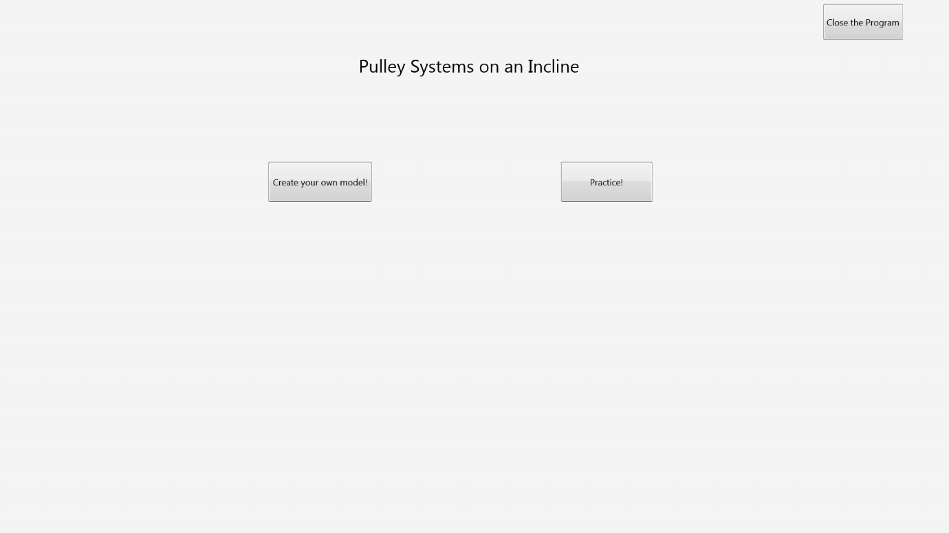Main Menu Form:

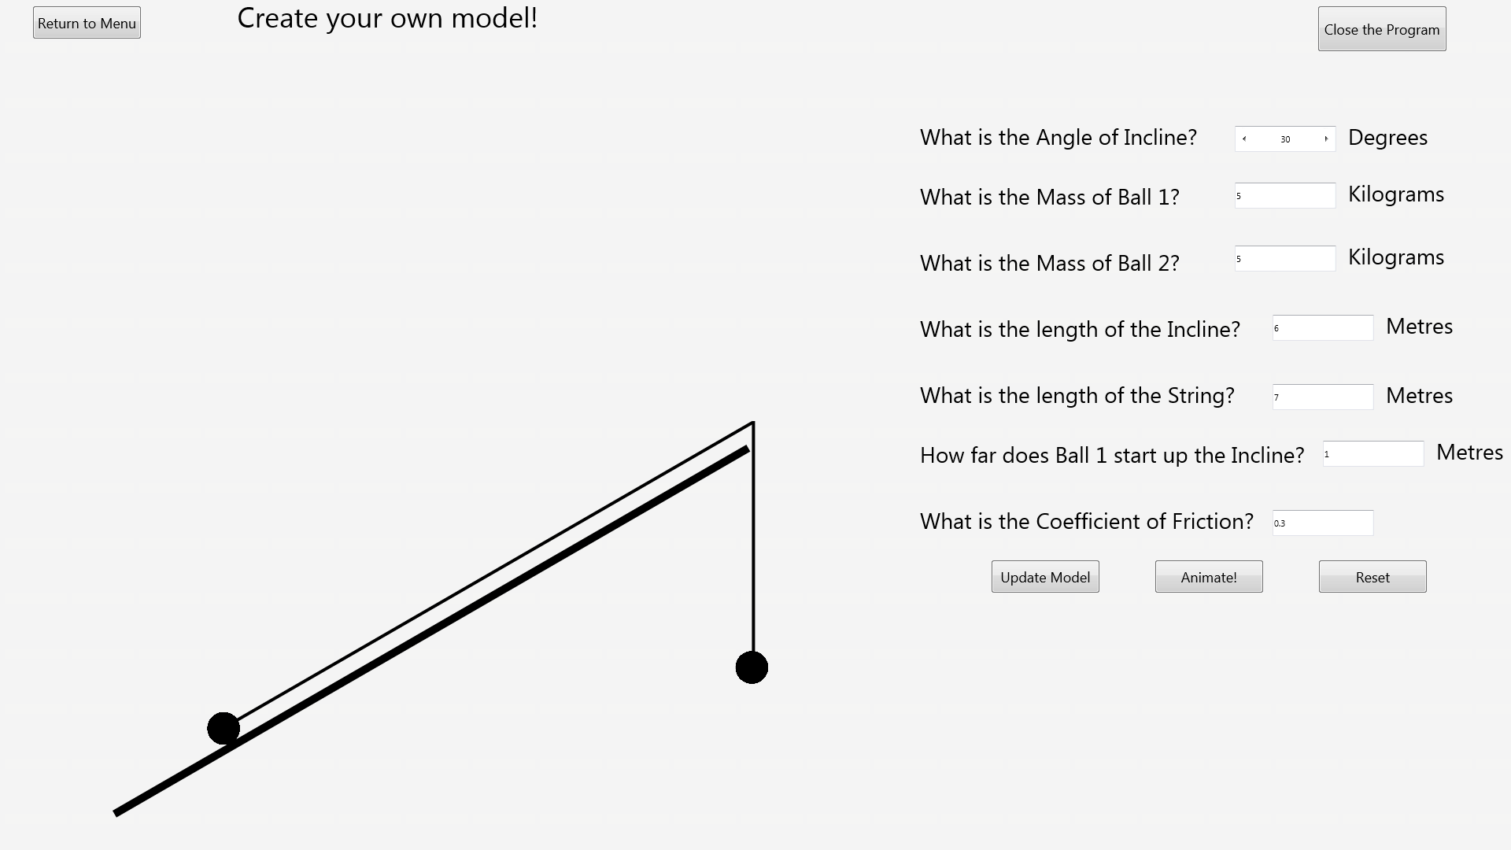Own Model Form:

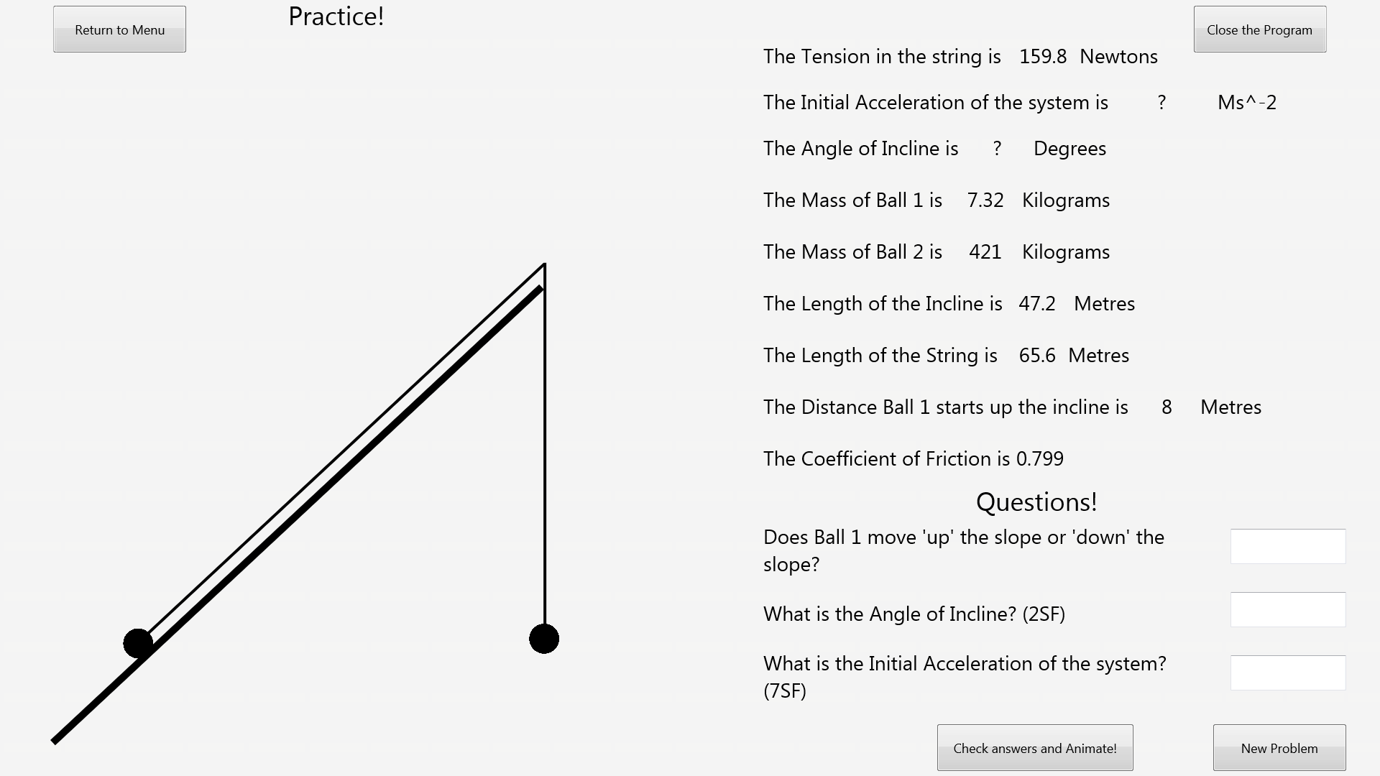Practice Form:

### Test Plan Tables

#### Integration Test Plan

|  |  |  |
| --- | --- | --- |
| **Test Number** | **Functionality to be tested** | **Expected Result** |
| 1 | Program Start-up | The program should start and the Main Menu should be shown. |
| 2 | Pressing the Close Program button on the Main Menu | The program should close. |
| 3 | Pressing the Create your own Model button on the Main Menu | The Create your own Model form should open. The model shown should be in its default configuration. |
| 4 | Pressing the Practice button on the Main Menu | The Practice form should open. A Random model with questions should be displayed. |
| 5 | Pressing the Return to Menu button on the Create your own Model form. | The Main Menu should open. |
| 6 | Pressing the Close Program Button on the Create your own Model Form. | The program should close. |
| 7 | Pressing the Return to Menu button on the Practice form. | The Main Menu should open. |
| 8 | Pressing the Close Program Button on the Practice Form. | The program should close. |

#### System Test Plan

|  |  |  |  |  |  |
| --- | --- | --- | --- | --- | --- |
| **Test Number** | **Unit** | **Functionality to be tested** | **Type of Data** | **Data** | **Expected Result** |
| 9 | User Model | Where the user can enter the incline angle, make sure that normal data (between 0-90 non-inclusive) is accepted. | Normal | 1. Incline Angle: 37 | No output from the program, as the input is valid. |
| 10 | User Model | Where the user can enter the incline angle, make sure that boundary data (1 or 89) is accepted | Boundary | 1. Incline Angle: 89 | No output from the program, as the input is valid. |
| 11 | User Model | Where the user can enter the incline angle, make sure that erroneous data (less than 1 or greater than 89) is rejected. | Erroneous | 1. Incline Angle: -16 | The program should output an error message informing the user why the input is invalid and the incline angle should be reset to its default value (30). |
| 12 | User Model | Where the user can enter the Mass of Ball 1, make sure that normal data (A 3 digit or less positive real number) is accepted. | Normal | 1. Mass of Ball 1: 80 | No output from the program, as the input is valid. |
| 13 | User Model | Where the user can enter the Mass of Ball 1, make sure that boundary data (0.01 or 999) is accepted. | Boundary | 1. Mass of Ball 1: 999 | No output from the program, as the input is valid. |
| 14 | User Model | Where the user can enter the Mass of Ball 1, make sure that erroneous data (Not a 3 digit or less positive number) is rejected. | Erroneous | 1. Mass of Ball 1: 4.253 | The program should output an error message informing the user why the input is invalid and the Mass of Ball 1 should be reset to its default value (5). |
| 15 | User Model | Where the user can enter the Mass of Ball 2, make sure that normal data (A 3 digit or less positive real number) is accepted. | Normal | 1. Mass of Ball 2: 812 | No output from the program, as the input is valid. |
| 16 | User Model | Where the user can enter the Mass of Ball 2, make sure that boundary data (0.01 or 999) is accepted. | Boundary | 1. Mass of Ball 2: 0.01 | No output from the program, as the input is valid. |
| 17 | User Model | Where the user can enter the Mass of Ball 2, make sure that erroneous data (Not a 3 digit or less positive number) is rejected. | Erroneous | 1. Mass of Ball 2: -6.3 | The program should output an error message informing the user why the input is invalid and the Mass of Ball 2 should be reset to its default value (5). |
| 18 | User Model | Where the user can enter the length of the incline, make sure that normal data (A 3 digit or less positive real number) is accepted. | Normal | 1. Length of the Incline: 7.2 | No output from the program, as the input is valid. |
| 19 | User Model | Where the user can enter the length of the incline, make sure that boundary data (0.01 or 999) is accepted. | Boundary | 1. Length of the Incline: 999 | No output from the program, as the input is valid. |
| 20 | User Model | Where the user can enter the length of the incline, make sure that erroneous data (Not a 3 digit or less positive number) is rejected. | Erroneous | 1. Length of the Incline: 89.123 | The program should output an error message informing the user why the input is invalid and the length of the incline should be reset to its default value (6). |
| 21 | User Model | Where the user can enter the length of the string, make sure that normal data (A 3 digit or less positive real number) is accepted. | Normal | 1. Length of the String: 63.4 | No output from the program, as the input is valid. |
| 22 | User Model | Where the user can enter the length of the string, make sure that boundary data (0.01 or 999) is accepted. | Boundary | 1. Length of the String: 0.01 | No output from the program, as the input is valid. |
| 23 | User Model | Where the user can enter the length of the string, make sure that erroneous data (Not a 3 digit or less positive number) is rejected. | Erroneous | 1. Length of the String: -12.34 | The program should output an error message informing the user why the input is invalid and the length of the string should be reset to its default value (7). |
| 24 | User Model | Where the user can enter the distance Ball 1 starts up the incline, make sure that normal data (A 3 digit or less positive real number) is accepted. | Normal | 1. Distance Ball 1 Starts Up Incline: 121 | No output from the program, as the input is valid. |
| 25 | User Model | Where the user can enter the distance Ball 1 starts up the incline, make sure that boundary data (0.01 or 999) is accepted. | Boundary | 1. Distance Ball 1 Starts Up Incline: 999 | No output from the program, as the input is valid. |
| 26 | User Model | Where the user can enter the distance Ball 1 starts up the incline, make sure that erroneous data (Not a 3 digit or less positive number) is rejected. | Erroneous | 1. Distance Ball 1 Starts Up Incline: 49883 | The program should output an error message informing the user why the input is invalid and the distance Ball 1 starts up the incline should be reset to its default value (1). |
| 27 | User Model | Where the user can enter the coefficient of friction, make sure that normal data (A 4 digit or less real number greater than or equal to 0) is accepted. | Normal | 1. Coefficient of Friction: 0.762 | No output from the program, as the input is valid. |
| 28 | User Model | Where the user can enter the coefficient of friction, make sure that boundary data (0) is accepted. | Boundary | 1. Coefficient of Friction: 0 | No output from the program, as the input is valid. |
| 29 | User Model | Where the user can enter the coefficient of friction, make sure that erroneous data (Not a 4 digit or less real number greater than or equal to 0) is rejected. | Erroneous | 1. Coefficient of Friction: 0.3459 | The program should output an error message informing the user why the input is invalid and the coefficient of friction should be reset to its default value (0.3). |
| 30 | User Model | When the update model button is pressed, normal data satisfying the inequality distance ball 1 starts up incline < length of incline should be accepted. | Normal | 1. Distance Ball 1 Starts Up Incline: 2.1  2. Length of Incline: 6.4 | The model on the left side of the screen should update to the changed configuration. |
| 31 | User Model | When the update model button is pressed, boundary data satisfying the inequality distance ball 1 starts up incline < length of incline should be accepted. | Boundary | 1. Distance Ball 1 Starts Up Incline: 6.4  2. Length of Incline: 6.41  ***3. Length of String: 2.24 (Note this is only used to stop other validation checks from kicking in).*** | The model on the left side of the screen should update to the changed configuration. |
| 32 | User Model | When the update model button is pressed, erroneous data that doesn’t satisfy the inequality distance ball 1 starts up incline < length of incline should be rejected. | Erroneous | 1. Distance Ball 1 Starts Up Incline: 18.4  2. Length of Incline: 3 | The program should output an error message informing the user why the inputs are invalid and the model on the left side of the screen should reset to its default. |
| 33 | User Model | When the update model button is pressed, normal data satisfying the inequality distance ball 1 starts up incline + length of string > length of incline should be accepted. | Normal | 1. Distance Ball 1 Starts Up Incline: 16  2. Length of Incline: 25  3. Length of String: 12 | The model on the left side of the screen should update to the changed configuration. |
| 34 | User Model | When the update model button is pressed, boundary data satisfying the inequality distance ball 1 starts up incline + length of string > length of incline should be accepted. | Boundary | 1. Distance Ball 1 Starts Up Incline: 3.29  2. Length of Incline: 7.41  3. Length of String: 4.13 | The model on the left side of the screen should update to the changed configuration. |
| 35 | User Model | When the update model button is pressed, erroneous data that doesn’t satisfy the inequality distance ball 1 starts up incline + length of string > length of incline should be rejected. | Erroneous | 1. Distance Ball 1 Starts Up Incline: 22  2. Length of Incline: 83  3. Length of String: 34.6 | The program should output an error message informing the user why the inputs are invalid and the model on the left side of the screen should reset to its default. |
| 36 | User Model | When the update model button is pressed, normal data satisfying the inequality (length of the incline* Sin(incline angle)) – length of the string + length of the incline – distance Ball 1 starts up the incline > 0should be accepted. | Normal | 1. Distance Ball 1 Starts Up Incline: 2.1  2. Length of Incline: 3.91  3. Length of String: 2.98  4. Incline Angle: 30 | The model on the left side of the screen should update to the changed configuration. |
| 37 | User Model | When the update model button is pressed, boundary data satisfying the inequality (length of the incline* Sin(incline angle)) – length of the string + length of the incline – distance Ball 1 starts up the incline > 0should be accepted. | Boundary | 1. Distance Ball 1 Starts Up Incline: 2.99  2. Length of Incline: 4  3. Length of String: 3  4. Incline Angle: 30 | The model on the left side of the screen should update to the changed configuration. |
| 38 | User Model | When the update model button is pressed, erroneous data that doesn’t satisfy the inequality (length of the incline* Sin(incline angle)) – length of the string + length of the incline – distance Ball 1 starts up the incline > 0should be rejected. | Erroneous | 1. Distance Ball 1 Starts Up Incline: 23.2  2. Length of Incline: 32  3. Length of String: 487  4. Incline Angle: 47 | The program should output an error message informing the user why the inputs are invalid and the model on the left side of the screen should reset to its default. |
| 39 | User Model | When the animate model button is pressed and the configuration is such that Ball 1 would move down the slope, the model should animate to reflect this. | Normal | 1. Incline Angle: 40  2. Mass of Ball 1: 120  3. Mass of Ball 2: 20.2  4. Length of Incline: 4.52  5. Length of String: 5.8  6. Distance Ball 1 Starts Up Incline: 1.19  7. Coefficient of Friction: 0.213 | The model should animate such that Ball 1 moves down the slope. |
| 40 | User Model | When the animate model button is pressed and the configuration is such that Ball 1 would move up the slope, the model should animate to reflect this. | Normal | 1. Incline Angle: 27  2. Mass of Ball 1: 44  3. Mass of Ball 2: 89.4  4. Length of Incline: 9.1  5. Length of String: 9.21  6. Distance Ball 1 Starts Up Incline: 0.7  7. Coefficient of Friction: 0.41 | The model should animate such that Ball 1 moves up the slope. |
| 41 | User Model | When the animate model button is pressed and the configuration is such that the Balls wouldn’t move, no animation should occur and a message should display explaining to the user why this has happened. | Normal | 1. Incline Angle: 36  2. Mass of Ball 1: 9.83  3. Mass of Ball 2: 12  4. Length of Incline: 6.21  5. Length of String: 7.8  6. Distance Ball 1 Starts Up Incline: 1.4  7. Coefficient of Friction: 0.912 | The model should not animate, and a message should display explain to the user why the current configuration would not move. |
| 42 | User Model | When the animate model button is pressed, the initial acceleration of the system should be correctly calculated. This will be checked by using the debug tool within Delphi XE5 to see what the variable changes to. | Normal | 1. Incline Angle: 30  2. Mass of Ball 1: 4  3. Mass of Ball 2: 5.2  4. Length of Incline: 6.1  5. Length of String: 6.98  6. Distance Ball 1 Starts Up Incline: 0.98  7. Coefficient of Friction: 0.156 | Initial Acceleration is 2.83305… |
| 43 | User Model | When the animate model button is pressed, the extra displacement should be correctly calculated. This will be checked by using the debug tool within Delphi XE5 to see what the variable changes to. | Normal | 1. Incline Angle: 36  2. Mass of Ball 1: 11  3. Mass of Ball 2: 24.2  4. Length of Incline: 8.2  5. Length of String: 7.5  6. Distance Ball 1 Starts Up Incline: 2.3  7. Coefficient of Friction: 0.456 | Extra displacement is 1.30763… |
| 44 | User Model | When the Reset Button is pressed, the model should reset to its default. | Normal | None (Just a button click) | The model should reset to its default values and configuration. |
| 45 | Practice | When the Check Answers and Animate button is pressed, if the user’s answers are correct, a message should display informing the user and the model should begin to animate. | Normal | 1. All questions answered correctly (calculated beforehand on paper) | A message telling the user they got their answers right should be displayed. Following this, the model should animate based on its configuration. |
| 46 | Practice | When the Check Answers and Animate button is pressed, if the user’s answers are incorrect, a message should display informing the user which questions they got wrong. | Normal | 1. Question 1 and 3 answered incorrectly  2. Question 2 answered correctly (calculated beforehand on paper)  ***Note: I have chosen to just test this scenario to shorten the testing as I feel testing all possibilities would be fairly redundant. This scenario was chosen at random.*** | A message telling the user which answers they got wrong should be displayed. The model should not animate. |
| 47 | Practice | When the New Problem button is pressed, a new problem should be generated. | Normal | None (Just a button click) | The values in the top right of the form should change to a new configuration, with some listed as ‘?’. The questions should also be reset with new ones based on which values are listed as ‘?’. The model should update to reflect the new configuration. |

## Testing

For information about what functionality was tested and what data was used, cross-reference with the test plan. Screenshots can be found in the ‘Screenshot Evidence’ section after both of the testing tables. Video Evidence can be found in the accompanying USB drive in the Video Evidence folder.

### Integration Testing

|  |  |  |  |  |
| --- | --- | --- | --- | --- |
| **Test Number** | **Expected Result** | **Actual Result** | **Pass/Fail** | **Evidence Location** |
| 1 | The program should start and the Main Menu should be shown. | The program started up and the Main Menu was shown. | Pass | Screenshot Evidence: Test 1 |
| 2 | The program should close. | The program closed. | Pass | Screenshot Evidence: Test 2 |
| 3 | The Create your own Model form should open. The model shown should be in its default configuration. | The Create your own Model form opened and the model shown was in its default configuration. | Pass | Screenshot Evidence: Test 3 |
| 4 | The Practice form should open. A Random model with questions should be displayed. | The Practice form opened and a random model with questions was displayed. | Pass | Screenshot Evidence: Test 4 |
| 5 | The Main Menu should open. | The Main Menu opened. | Pass | Screenshot Evidence: Test 5 |
| 6 | The program should close. | The program closed. | Pass | Screenshot Evidence: Test 6 |
| 7 | The Main Menu should open. | The Main Menu opened. | Pass | Screenshot Evidence: Test 7 |
| 8 | The program should close. | The program closed. | Pass | Screenshot Evidence: Test 8 |

### System Testing

|  |  |  |  |  |
| --- | --- | --- | --- | --- |
| **Test Number** | **Expected Result** | **Actual Result** | **Pass/Fail** | **Evidence Location** |
| 9 | No output from the program, as the input is valid. | The program produced now output. | Pass | Screenshot Evidence: Test 9 |
| 10 | No output from the program, as the input is valid. | The program produced no output. | Pass | Screenshot Evidence: Test 10 |
| 11 | The program should output an error message informing the user why the input is invalid and the Incline angle should be reset to its default value (30). | The program outputted an error message and then reset the Incline Angle to 30. | Pass | Screenshot Evidence: Test 11 |
| 12 | No output from the program, as the input is valid. | The program produced no output. | Pass | Screenshot Evidence: Test 12 |
| 13 | No output from the program, as the input is valid. | The program produced no output. | Pass | Screenshot Evidence: Test 13 |
| 14 | The program should output an error message informing the user why the input is invalid and the Mass of Ball 1 should be reset to its default value (5). | The program outputted an error message and then reset the Ball 1 Mass to 5. | Pass | Screenshot Evidence: Test 14 |
| 15 | No output from the program, as the input is valid. | The program produced no output. | Pass | Screenshot Evidence: Test 15 |
| 16 | No output from the program, as the input is valid. | The program produced no output. | Pass | Screenshot Evidence: Test 16 |
| 17 | The program should output an error message informing the user why the input is invalid and the Mass of Ball 2 should be reset to its default value (5). | The program outputted an error message and then reset the Ball 2 Mass to 5. | Pass | Screenshot Evidence: Test 17 |
| 18 | No output from the program, as the input is valid. | The program produced no output. | Pass | Screenshot Evidence: Test 18 |
| 19 | No output from the program, as the input is valid. | The program produced no output. | Pass | Screenshot Evidence: Test 19 |
| 20 | The program should output an error message informing the user why the input is invalid and the length of the incline should be reset to its default value (6). | The program outputted an error message and then reset the Incline Length to 6. | Pass | Screenshot Evidence: Test 20 |
| 21 | No output from the program, as the input is valid. | The program produced no output. | Pass | Screenshot Evidence: Test 21 |
| 22 | No output from the program, as the input is valid. | The program produced no output. | Pass | Screenshot Evidence: Test 22 |
| 23 | The program should output an error message informing the user why the input is invalid and the length of the string should be reset to its default value (7). | The program outputted an error message and then reset the String Length to 7. | Pass | Screenshot Evidence: Test 23 |
| 24 | No output from the program, as the input is valid. | The program produced no output. | Pass | Screenshot Evidence: Test 24 |
| 25 | No output from the program, as the input is valid. | The program produced no output. | Pass | Screenshot Evidence: Test 25 |
| 26 | The program should output an error message informing the user why the input is invalid and the distance Ball 1 starts up the incline should be reset to its default value (1). | The program outputted an error message and then reset the Distance Ball 1 starts up the incline to 1. | Pass | Screenshot Evidence: Test 26 |
| 27 | No output from the program, as the input is valid. | The program produced no output. | Pass | Screenshot Evidence: Test 27 |
| 28 | No output from the program, as the input is valid. | The program produced no output. | Pass | Screenshot Evidence: Test 28 |
| 29 | The program should output an error message informing the user why the input is invalid and the coefficient of friction should be reset to its default value (0.3). | The program outputted an error message and then reset the Coefficient of Friction to 0.3. | Pass | Screenshot Evidence: Test 29 |
| 30 | The model on the left side of the screen should update to the changed configuration. | The model updated to the new configuration. | Pass | Video Evidence: Test 30 |
| 31 | The model on the left side of the screen should update to the changed configuration. | The model updated to the new configuration. | Pass | Video Evidence: Test 31 |
| 32 | The program should output an error message informing the user why the inputs are invalid and the model on the left side of the screen should reset to its default. | The program produced an error message informing the user why the inputs were invalid and the model on the left side of the screen reset to default. | Pass | Video Evidence: Test 32 |
| 33 | The model on the left side of the screen should update to the changed configuration. | The model updated to the new configuration. | Pass | Video Evidence: Test 33 |
| 34 | The model on the left side of the screen should update to the changed configuration. | The model updated to the new configuration. | Pass | Video Evidence: Test 34 |
| 35 | The program should output an error message informing the user why the inputs are invalid and the model on the left side of the screen should reset to its default. | The program produced an error message informing the user why the inputs were invalid and the model on the left side of the screen reset to default. | Pass | Video Evidence: Test 35 |
| 36 | The model on the left side of the screen should update to the changed configuration. | The model updated to the new configuration. | Pass | Video Evidence: Test 36 |
| 37 | The model on the left side of the screen should update to the changed configuration. | The model updated to the new configuration. | Pass | Video Evidence: Test 37 |
| 38 | The program should output an error message informing the user why the inputs are invalid and the model on the left side of the screen should reset to its default. | The program produced an error message informing the user why the inputs were invalid and the model on the left side of the screen reset to default. | Pass | Video Evidence: Test 38 |
| 39 | The model should animate such that Ball 1 moves down the slope. | The model animated such that Ball 1 moved down the slope. | Pass | Video Evidence: Test 39 |
| 40 | The model should animate such that Ball 1 moves up the slope. | The model animated such that Ball 1 moved up the slope. | Pass | Video Evidence: Test 40 |
| 41 | The model should not animate, and a message should display explain to the user why the current configuration would not move. | The model didn’t animate and the program displayed a message explaining why. | Pass | Video Evidence: Test 41 |
| 42 | Initial Acceleration is 2.83305… | Initial Acceleration was correct. | Pass | Screenshot Evidence: Test 42 |
| 43 | Extra displacement is 1.30763… | Extra displacement was correct. | Pass | Screenshot Evidence: Test 43 |
| 44 | The model should reset to its default values and configuration. | The model reset to its default values and configuration. | Pass | Video Evidence: Test 44 |
| 45 | A message telling the user they got their answers right should be displayed. Following this, the model should animate based on its configuration. | The program displayed a message informing the user they got the questions correct. Once this was closed the model animated. | Pass | Video Evidence: Test 45 |
| 46 | A message telling the user which answers they got wrong should be displayed. The model should not animate. | The program displayed a message informing the user which questions they got wrong. The model didn’t animate. | Pass | Video Evidence: Test 46 |
| 47 | The values in the top right of the form should change to a new configuration, with some listed as ‘?’. The questions should also be reset with new ones based on which values are listed as ‘?’. The model should update to reflect the new configuration. | The values in the top right were updated to a new configuration. Those questions were also updated linking to the values who were listed as ‘?’. The model updated instantaneously to the new configuration. | Pass | Screenshot Evidence: Test 47 |

## Screenshot Evidence

### Test 1

Before:

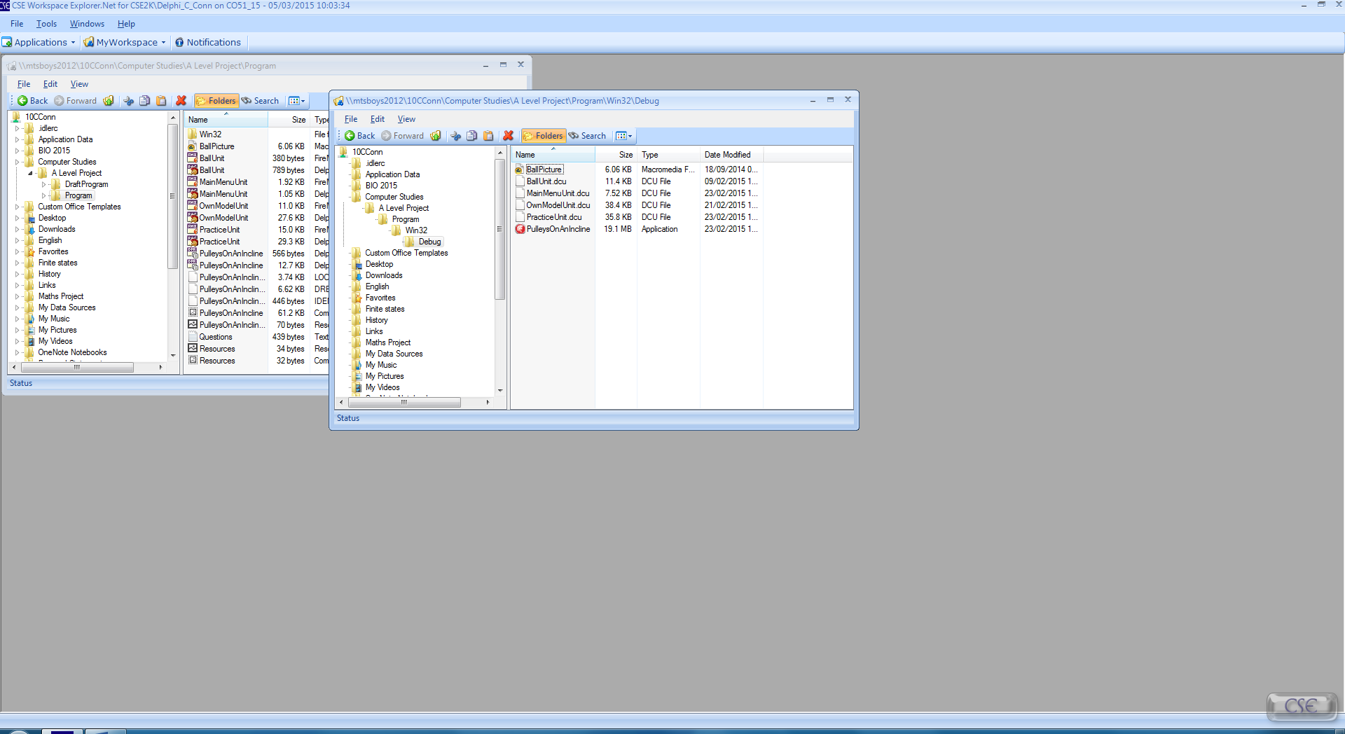

After:

### Test 2

Before:

After:

### Test 3

Before:

After:

### Test 4

Before:

After:

### Test 5

Before:

After:

### Test 6

Before:

After:

### Test 7

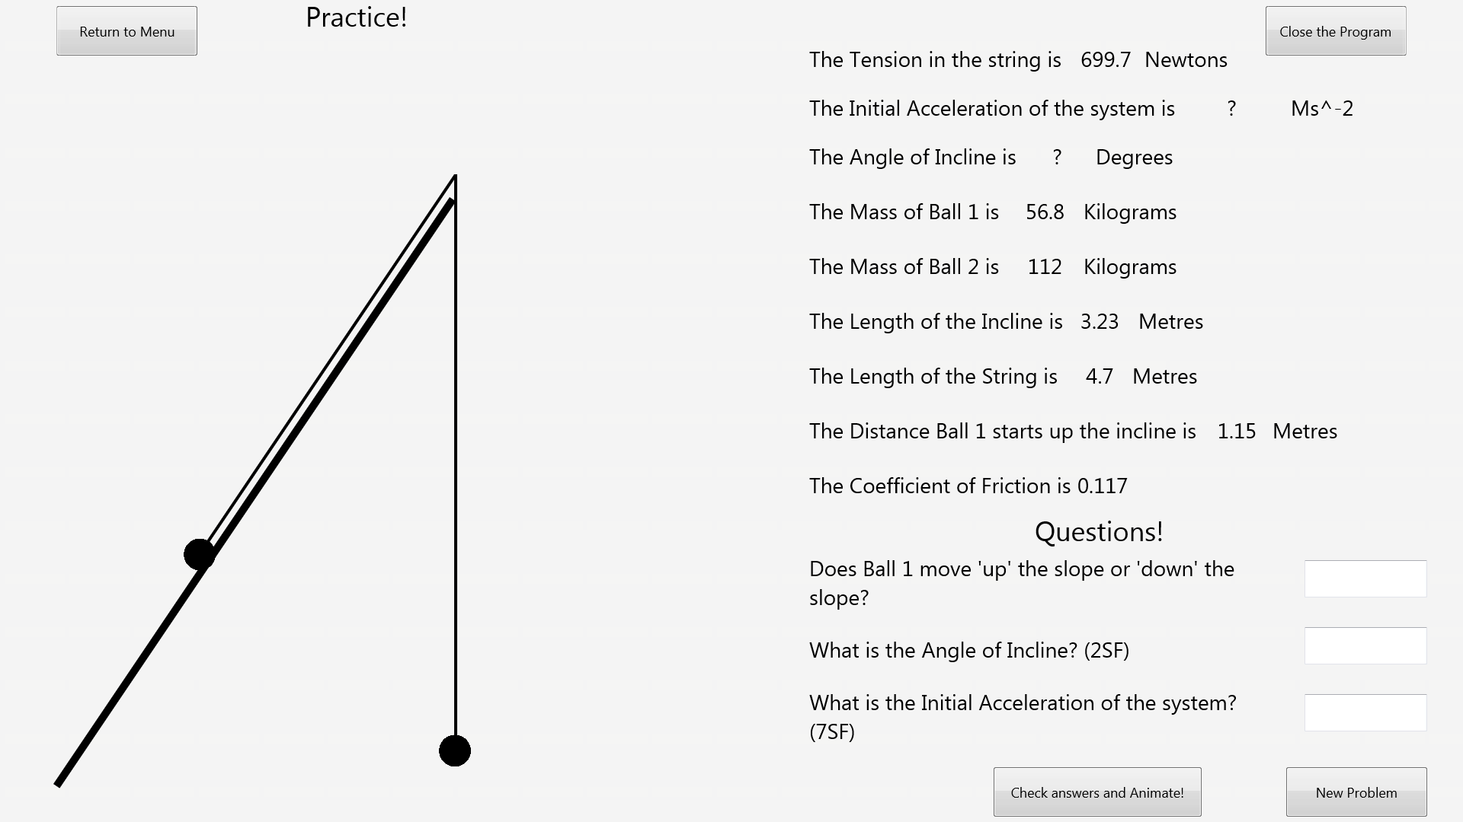Before:

After:

### Test 8

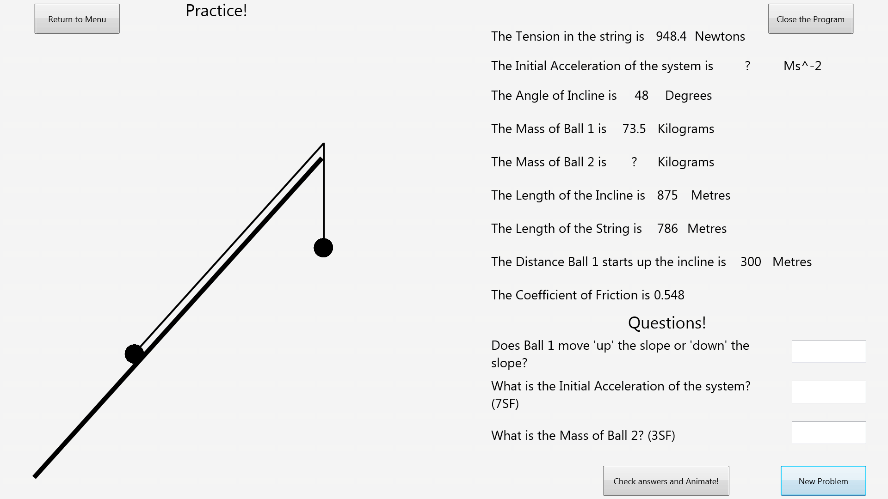Before:

After:

### Test 9

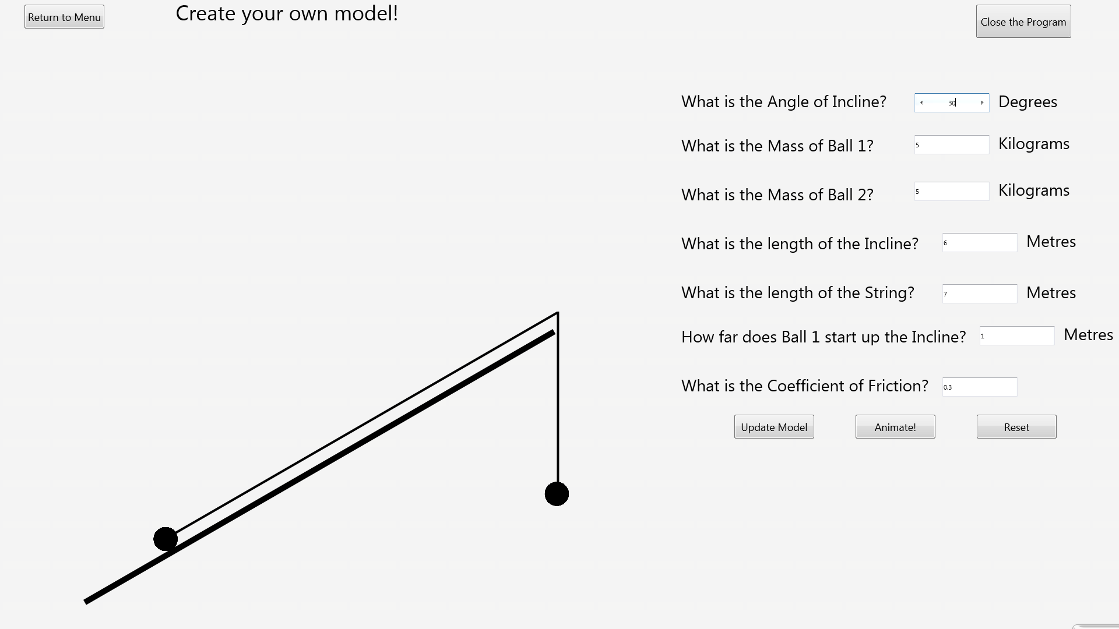Before:

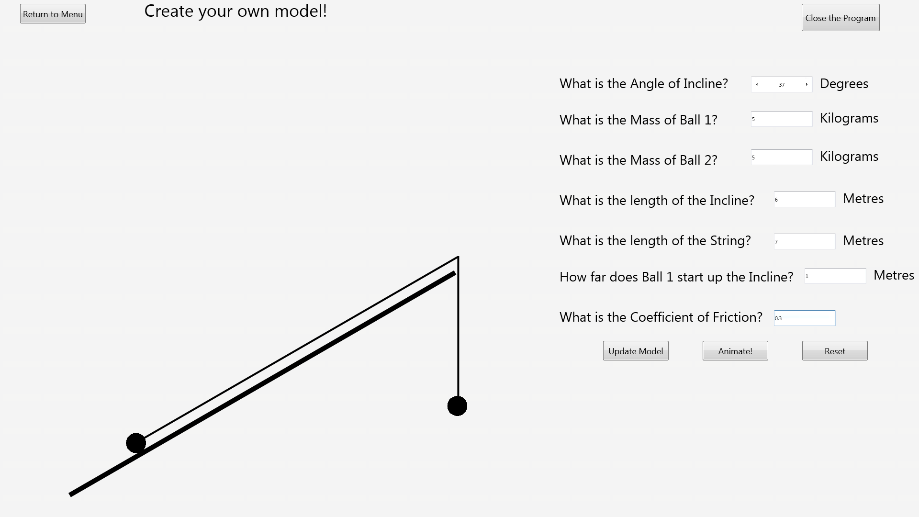After:

### Test 10

Before:

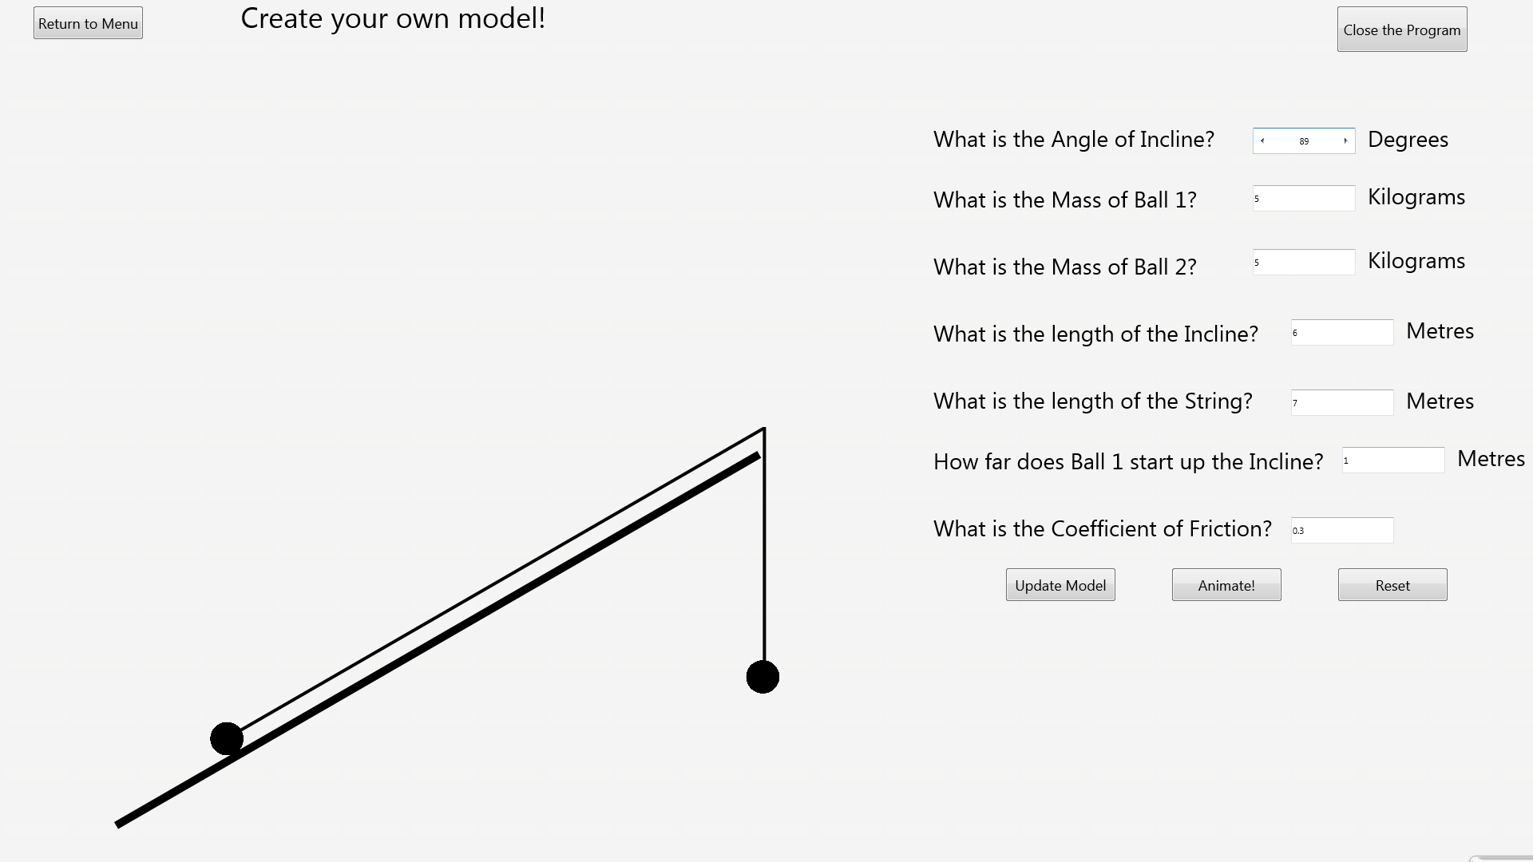After:

### Test 11

Before:

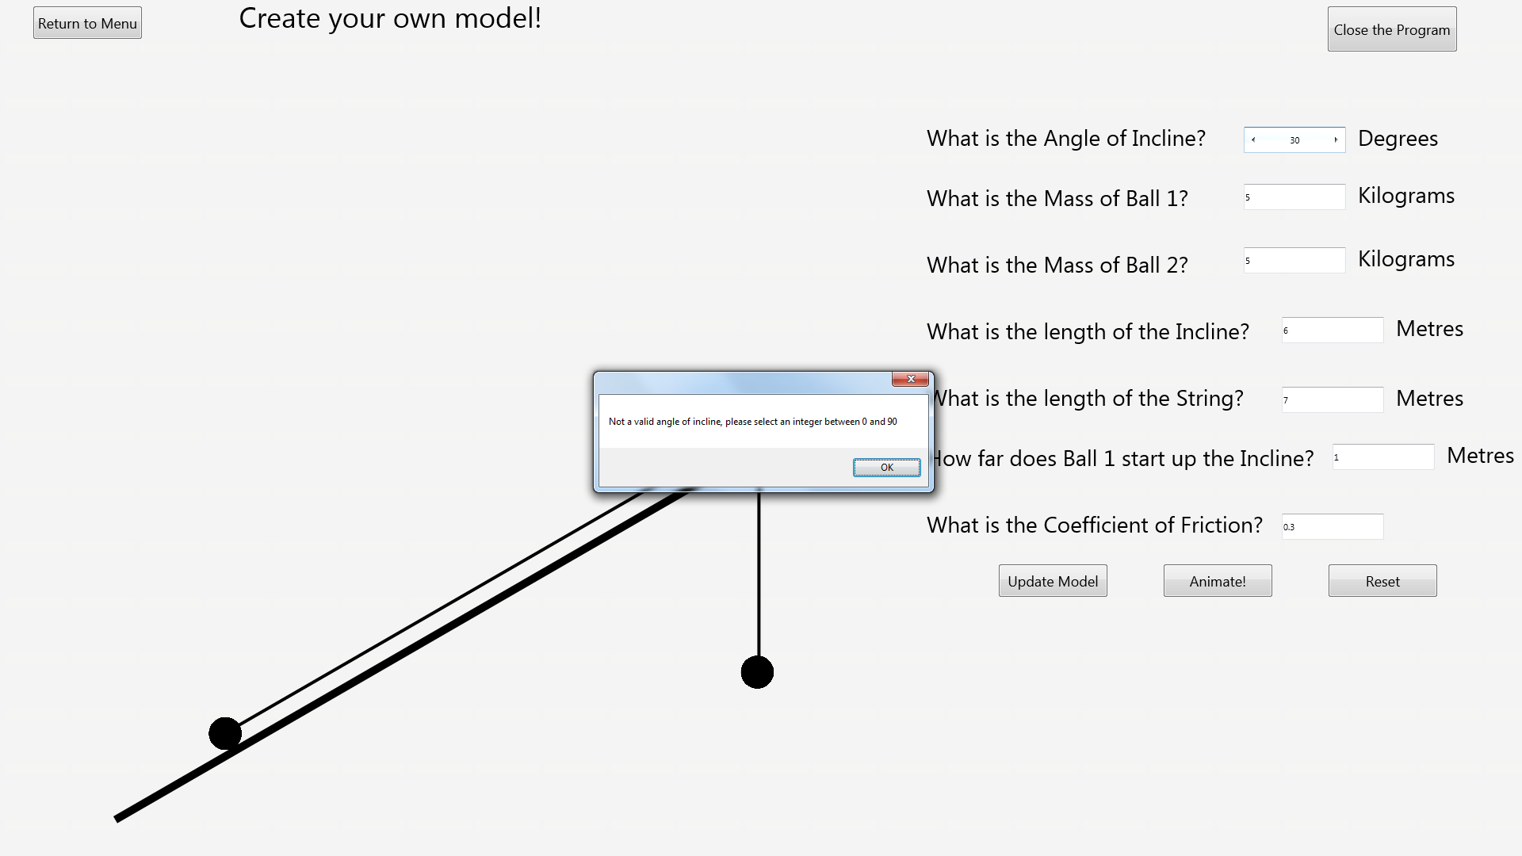After:

### Test 12

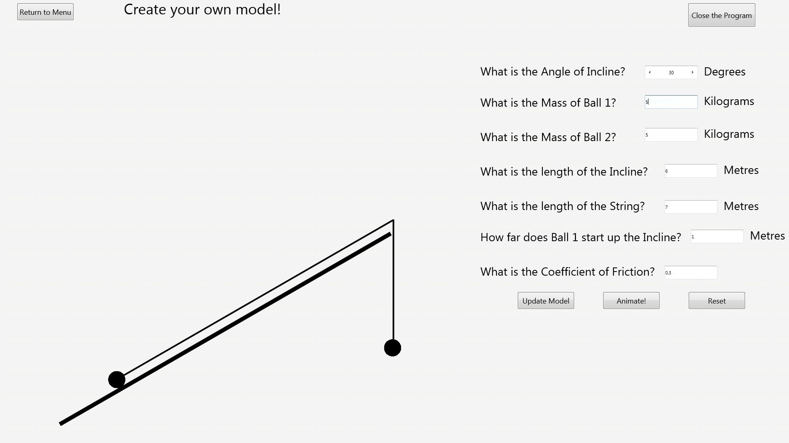Before:

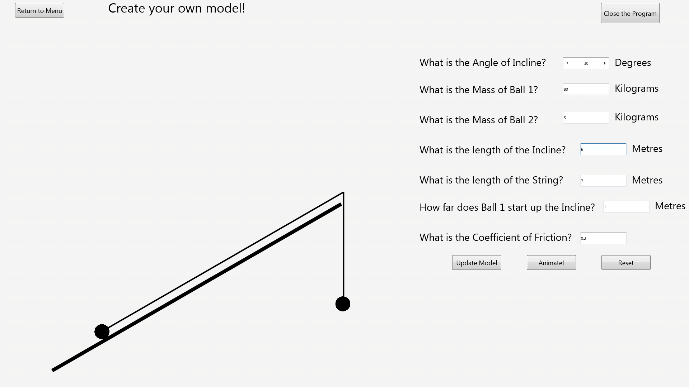After:

### Test 13

Before:

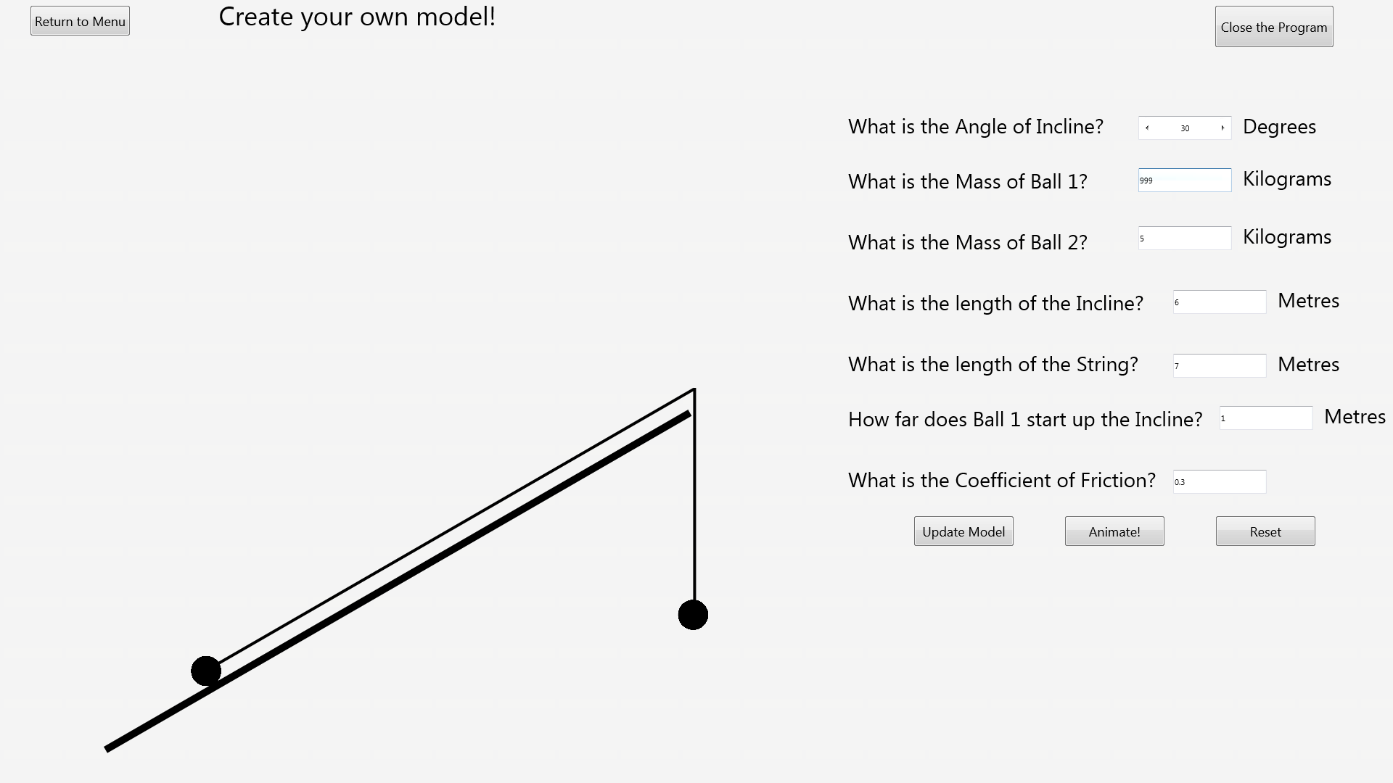After:

### Test 14

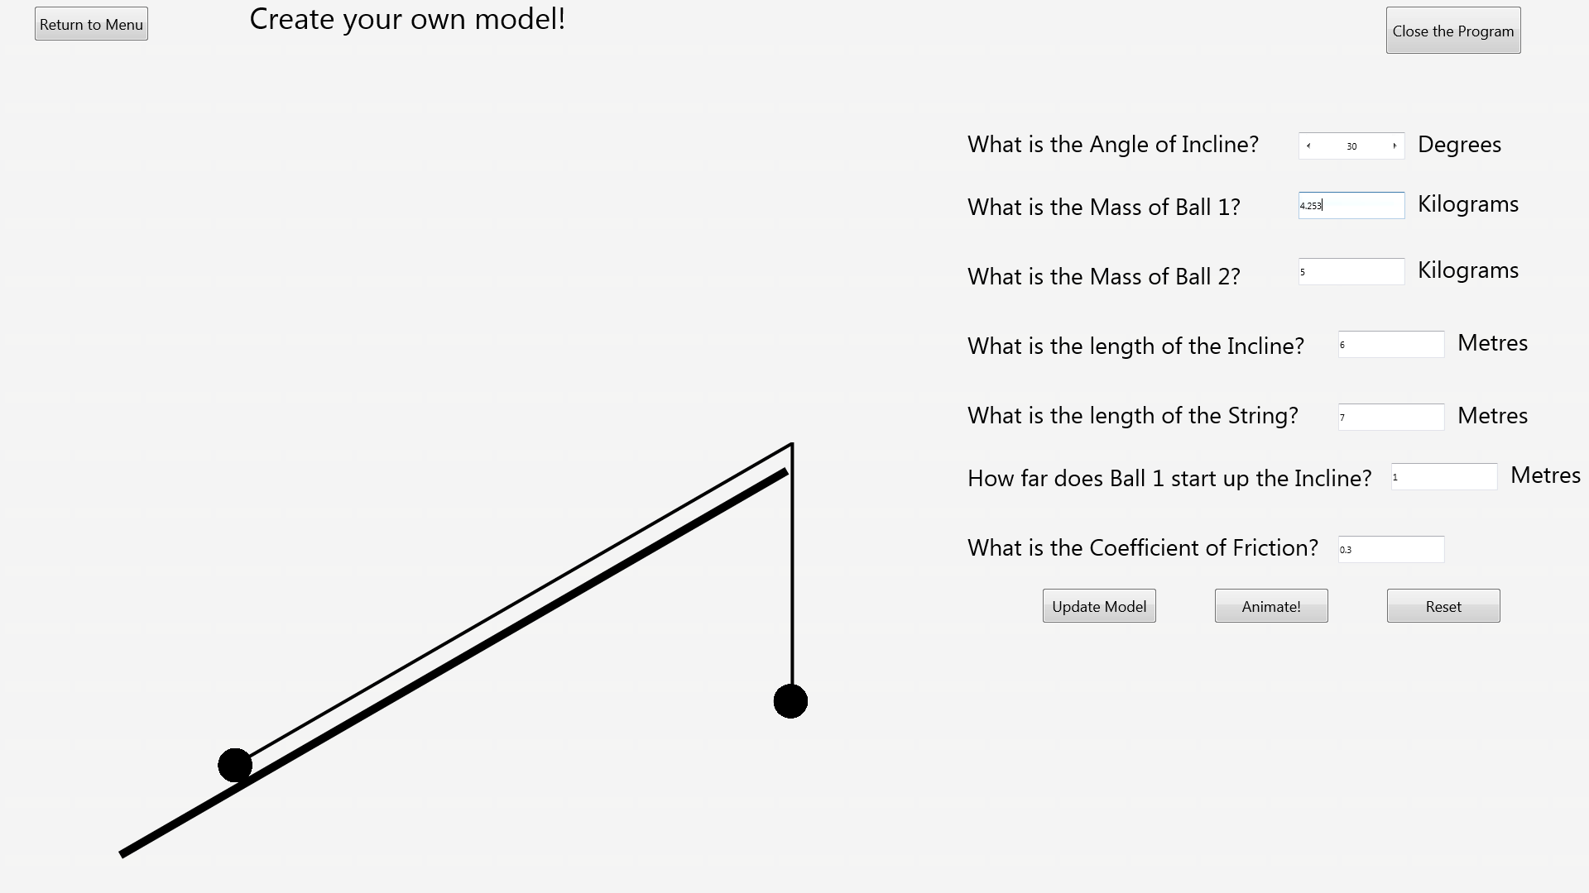Before:

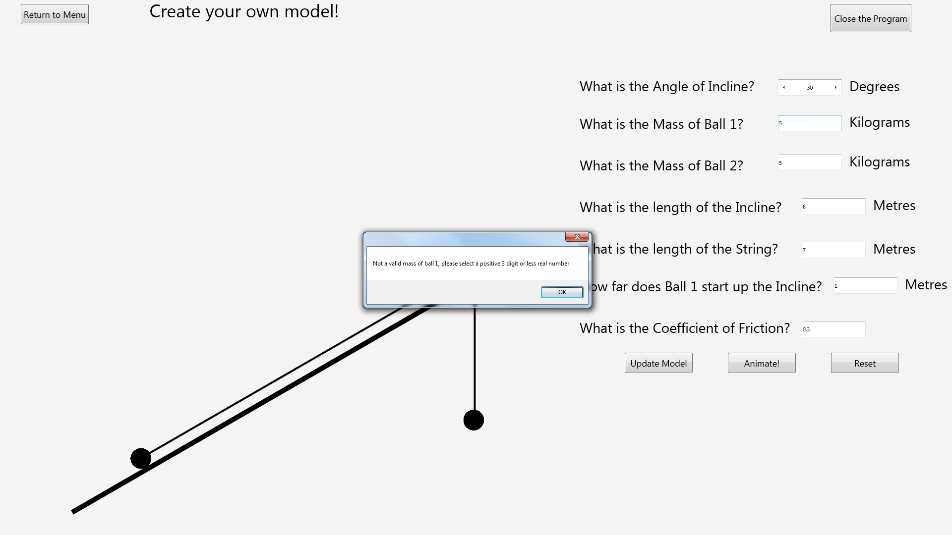After:

### Test 15

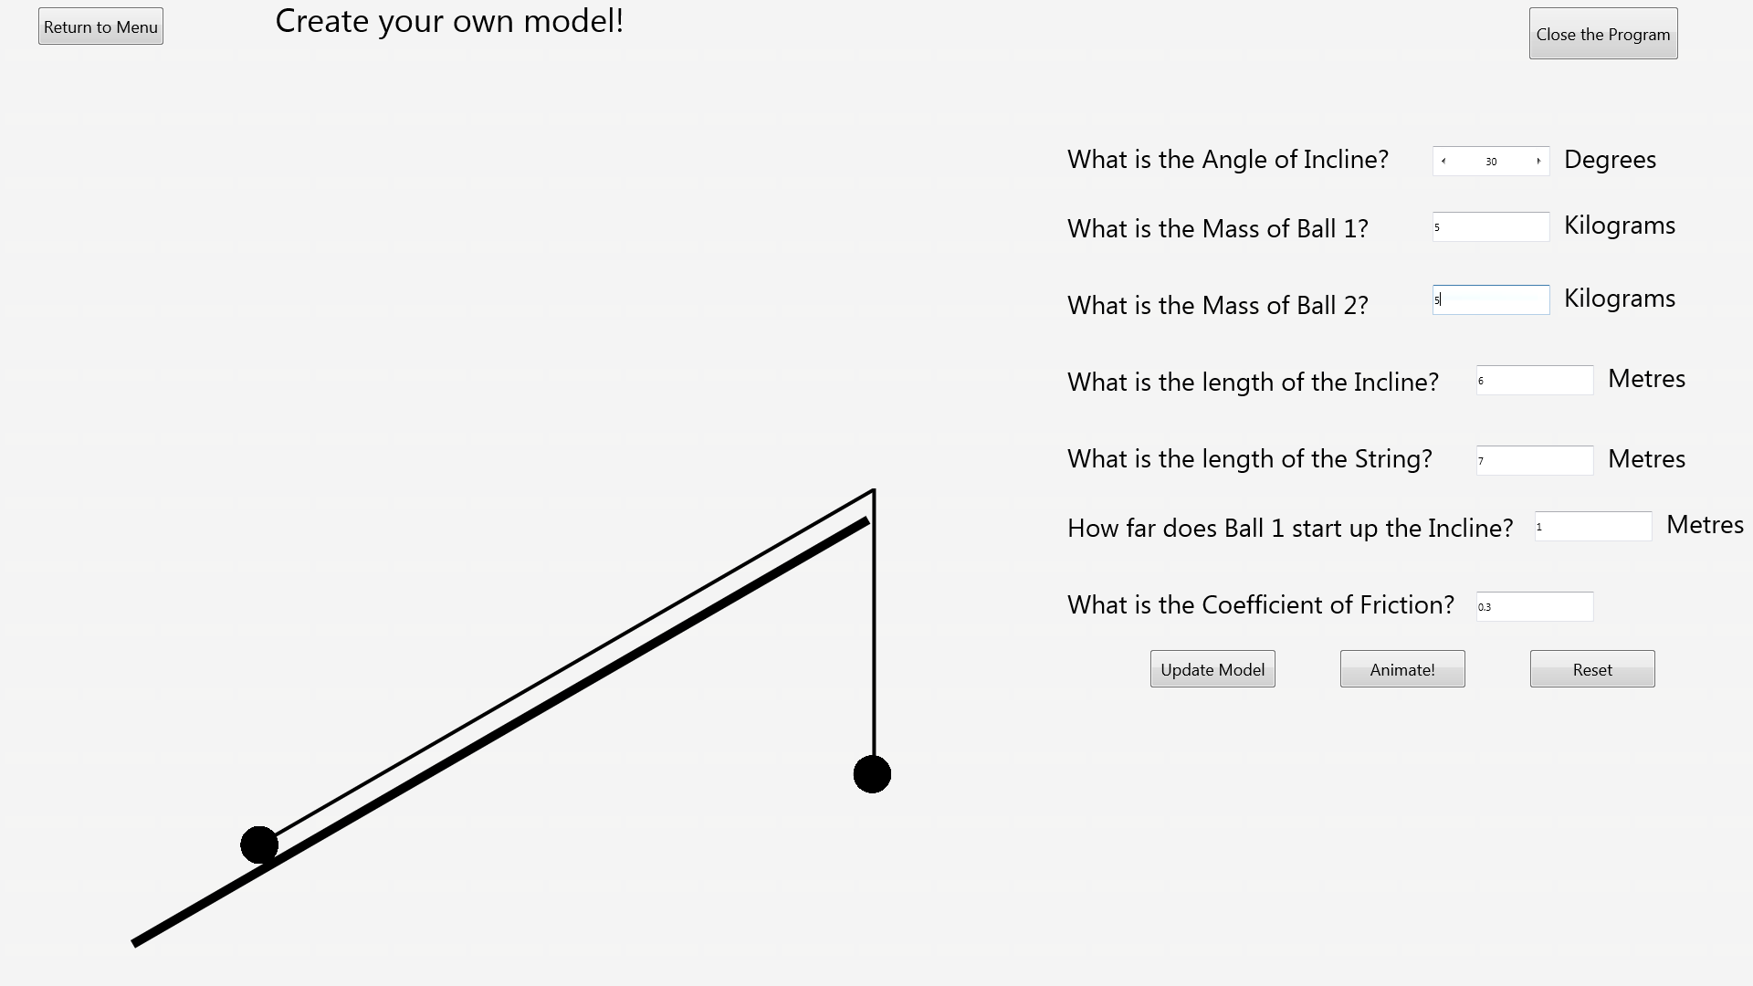Before:

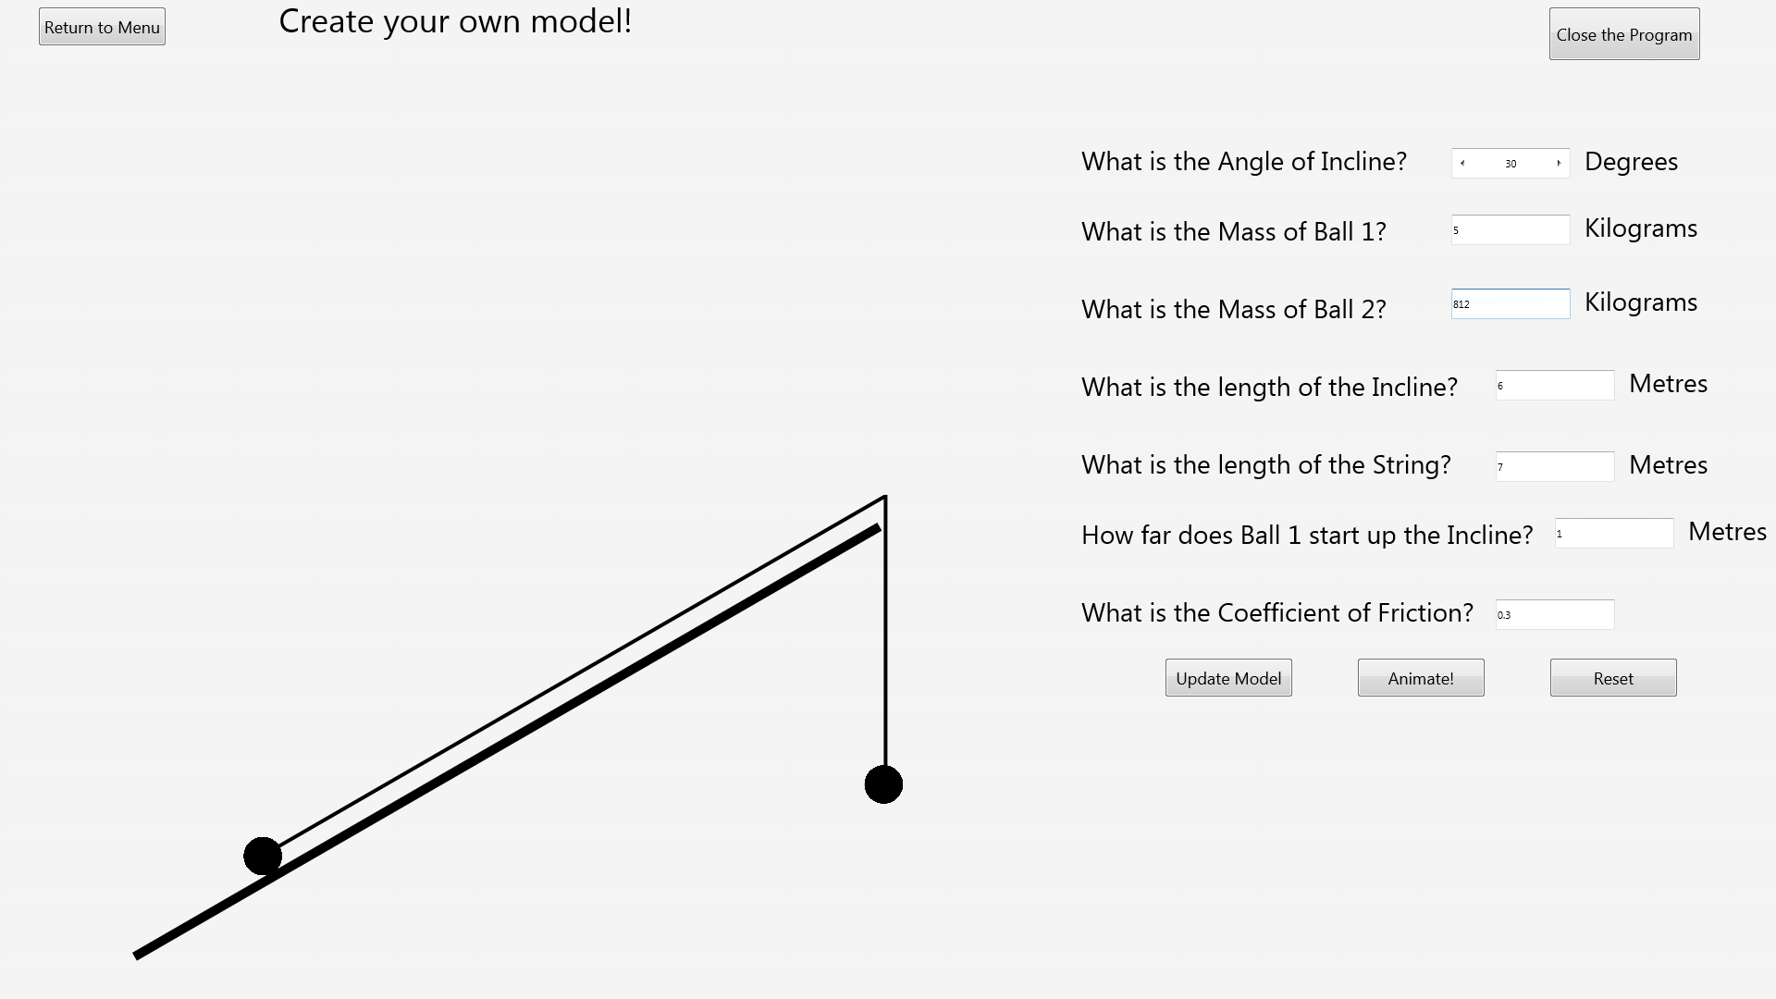After:

### Test 16

Before:

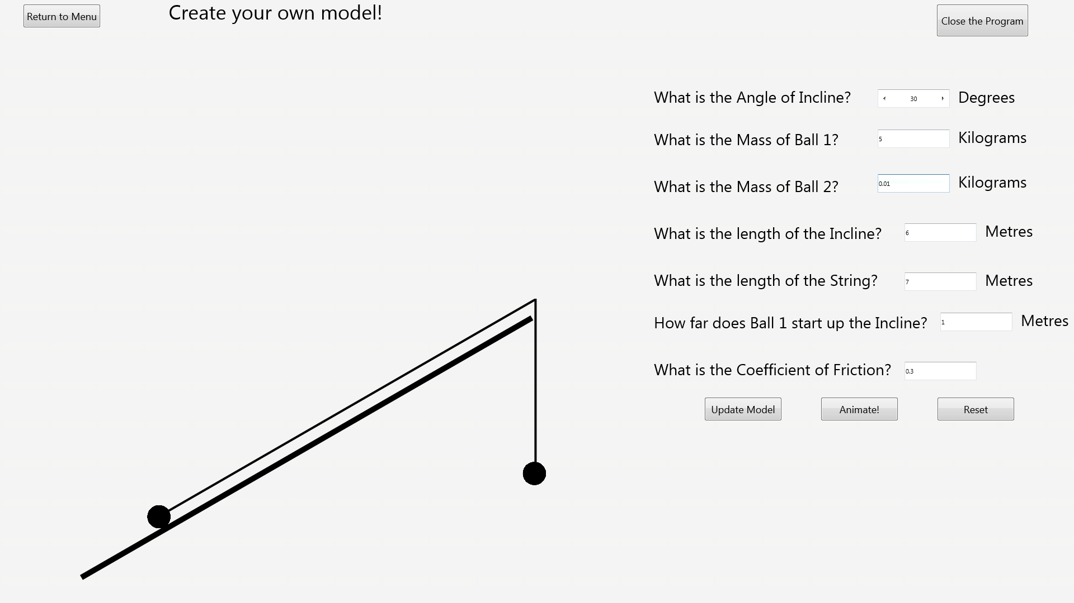After:

### Test 17

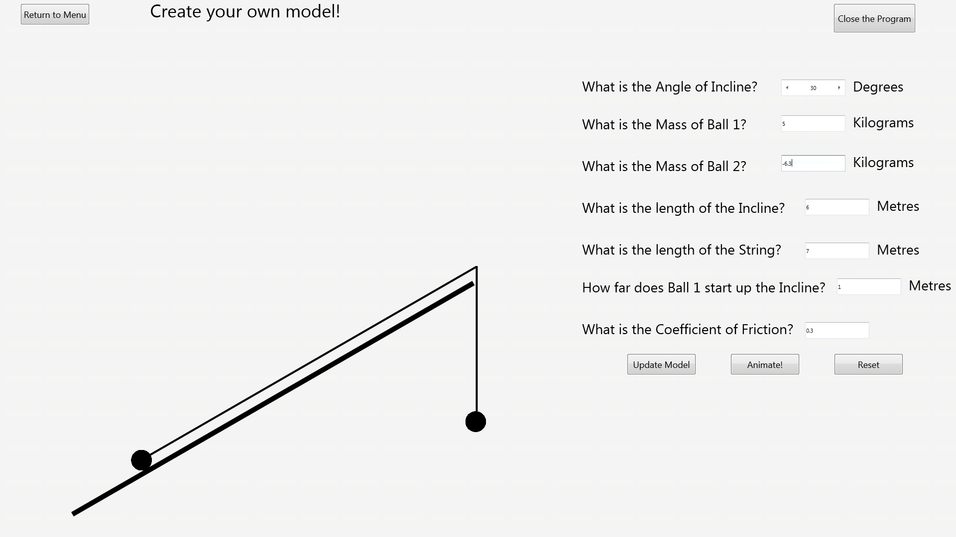Before:

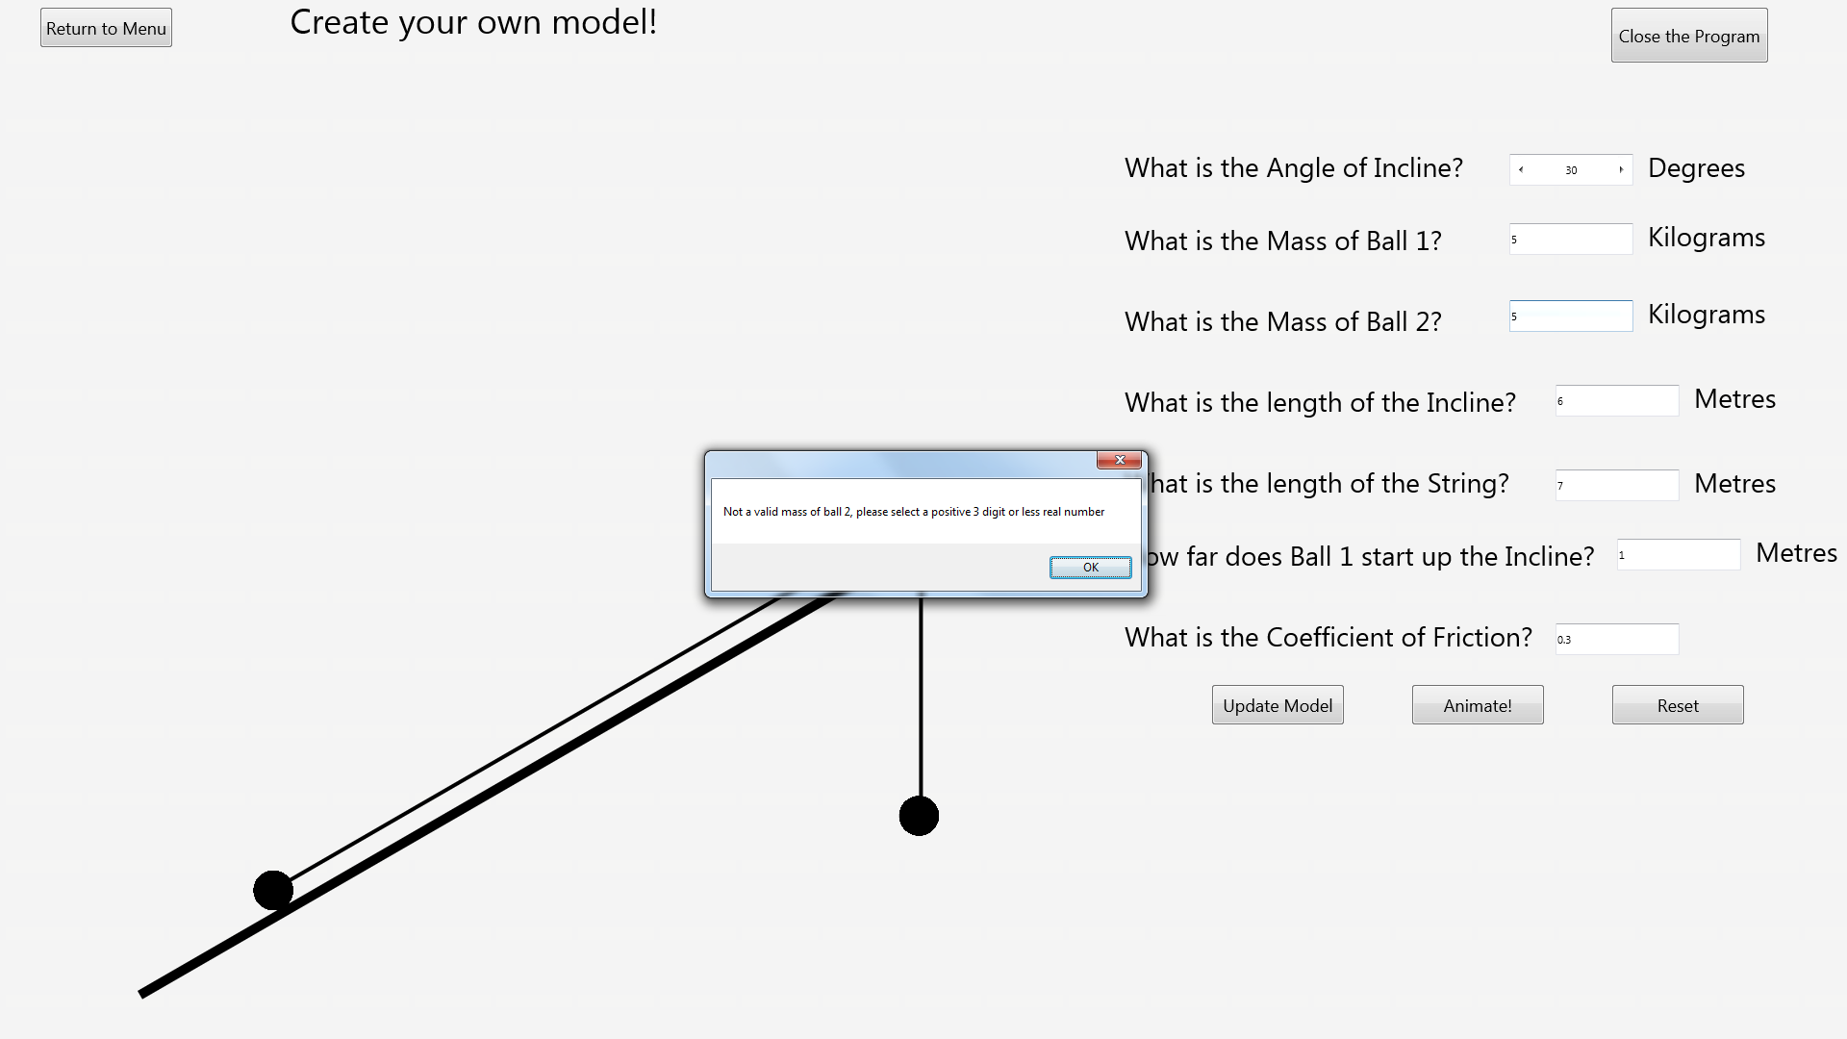After:

### Test 18

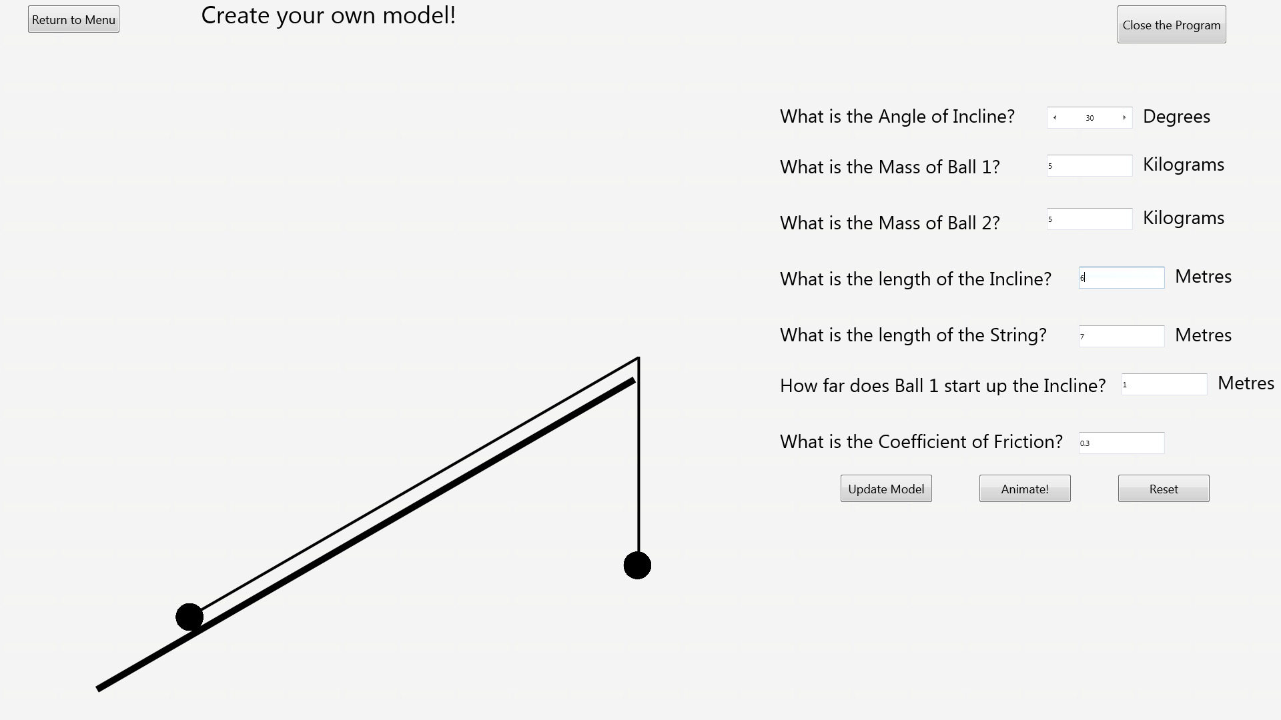Before:

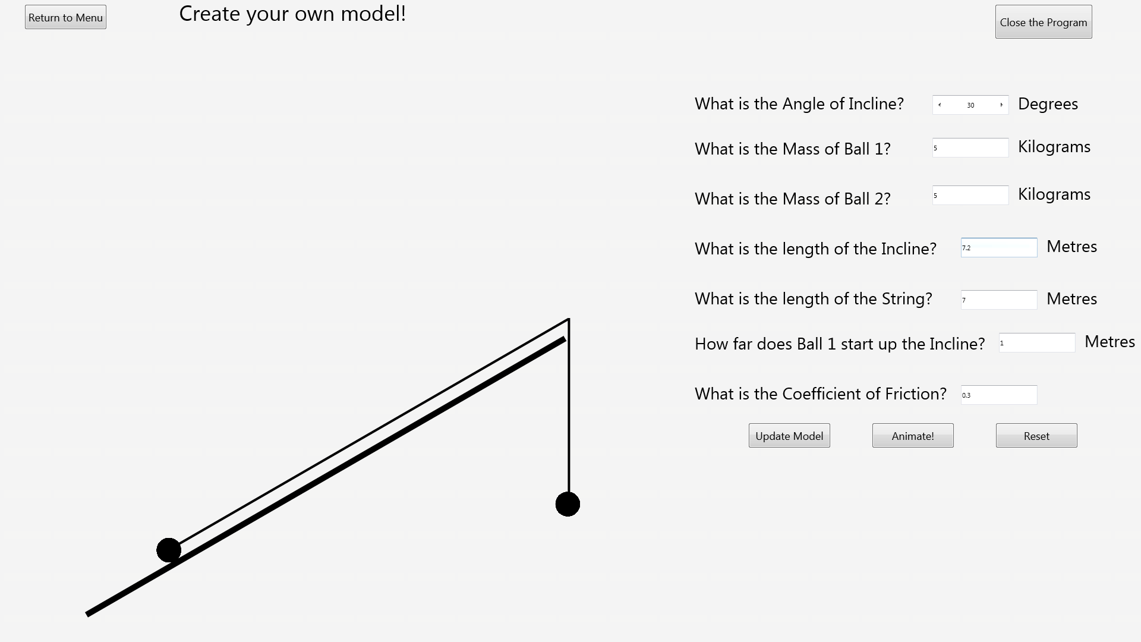After:

### Test 19

Before:

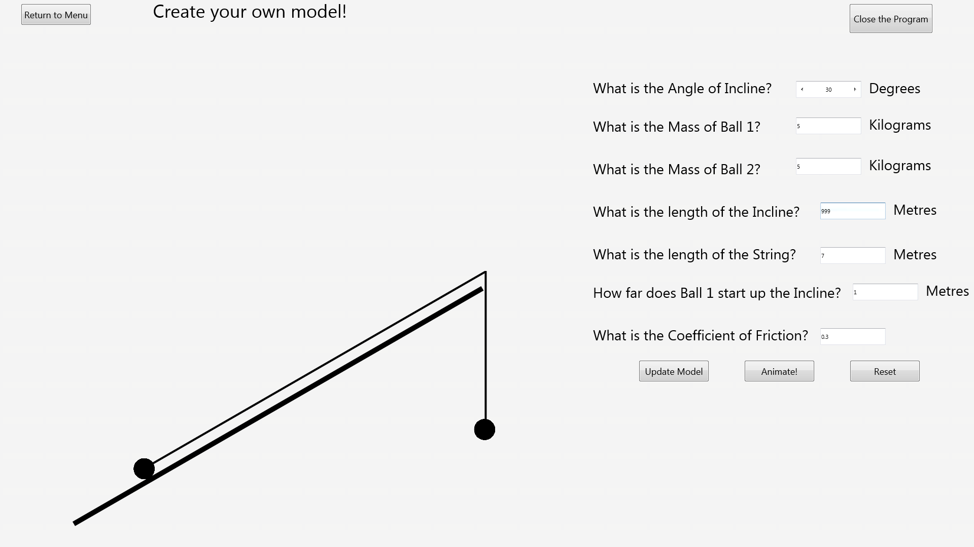After:

### Test 20

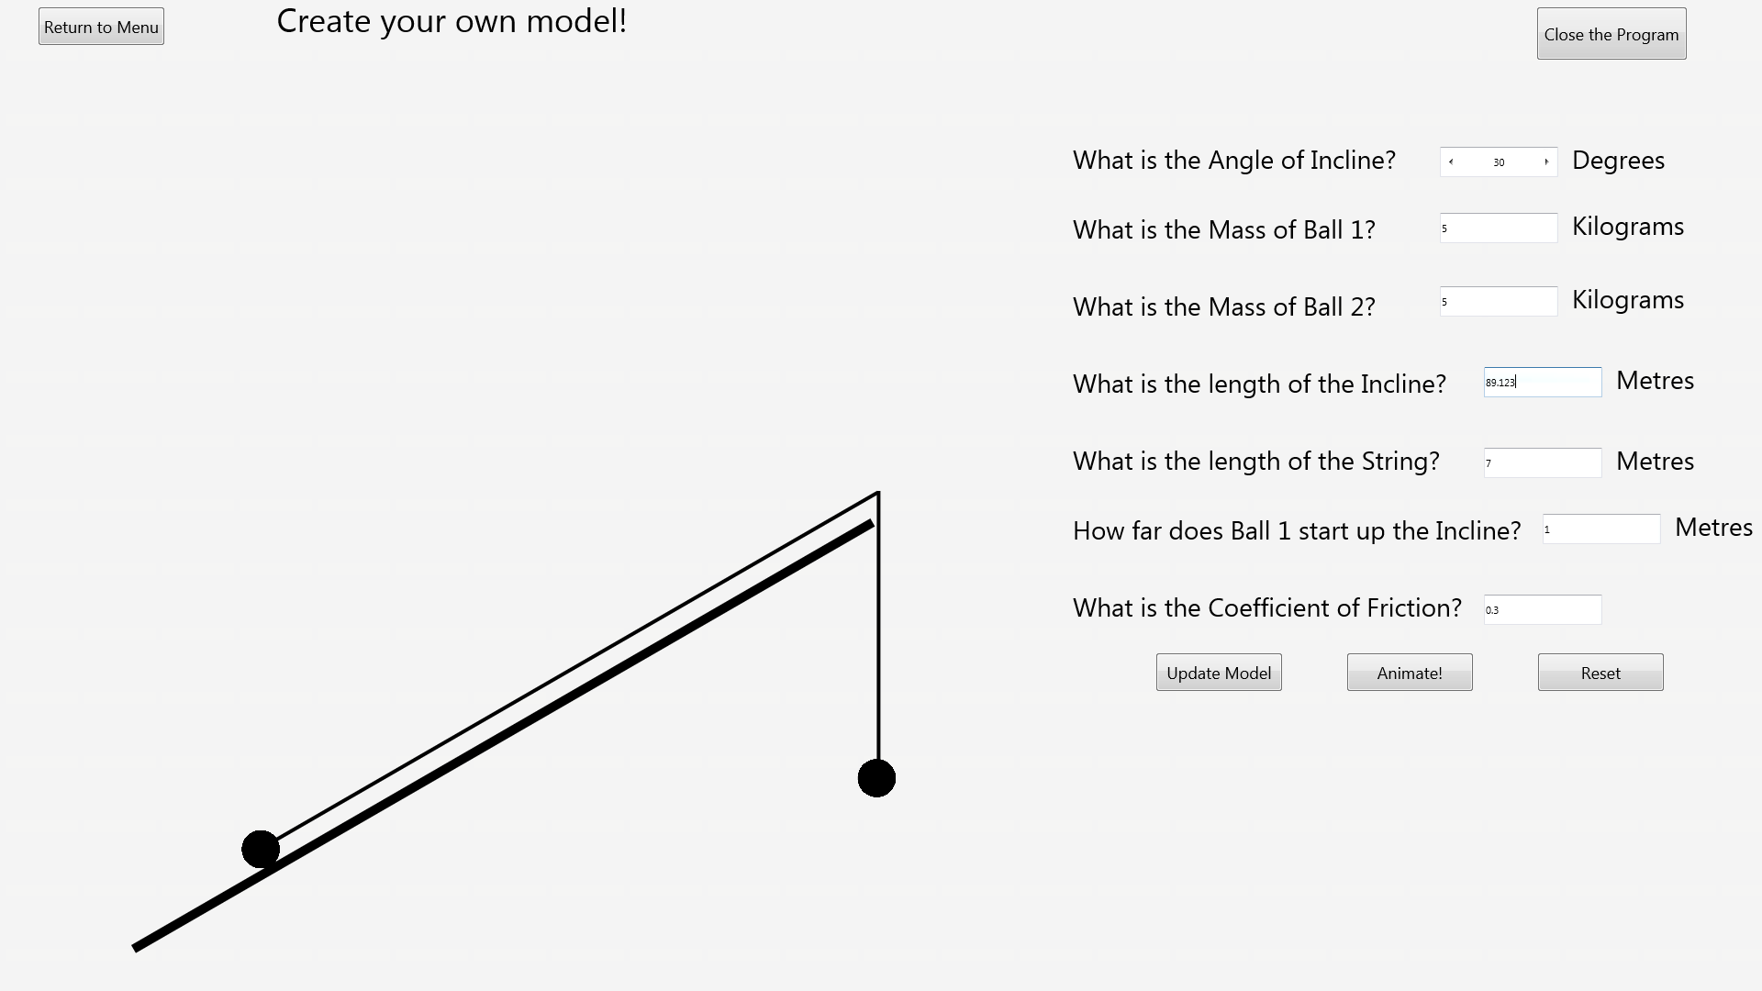Before:

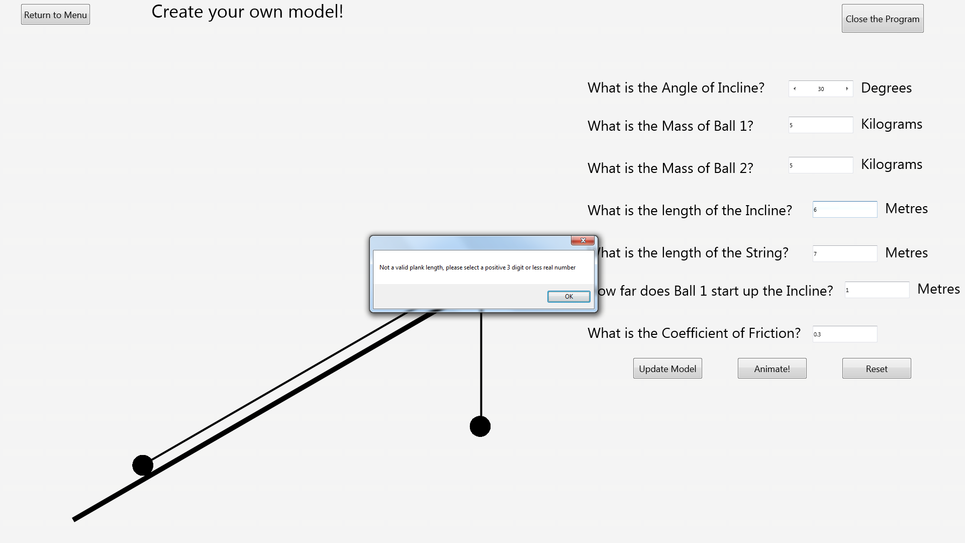After:

### Test 21

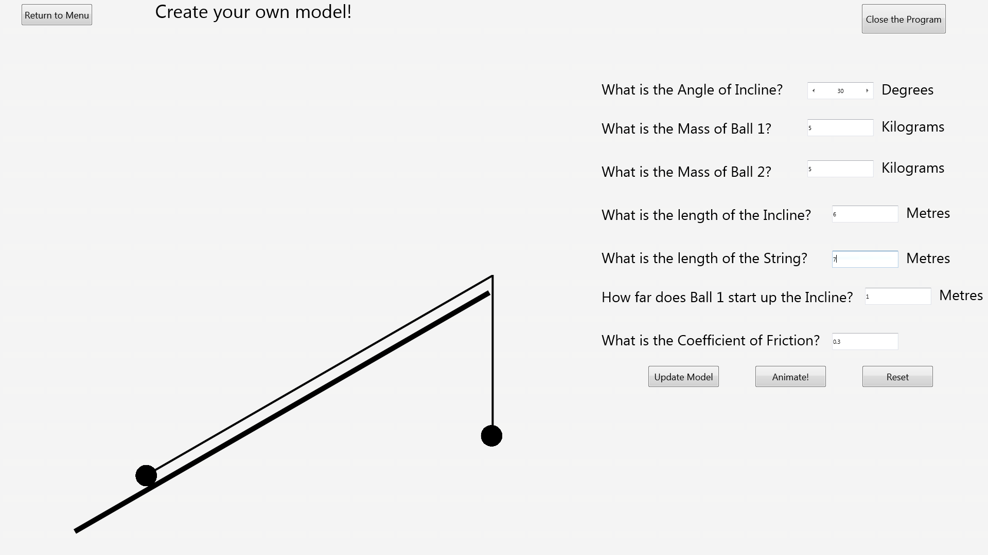Before:

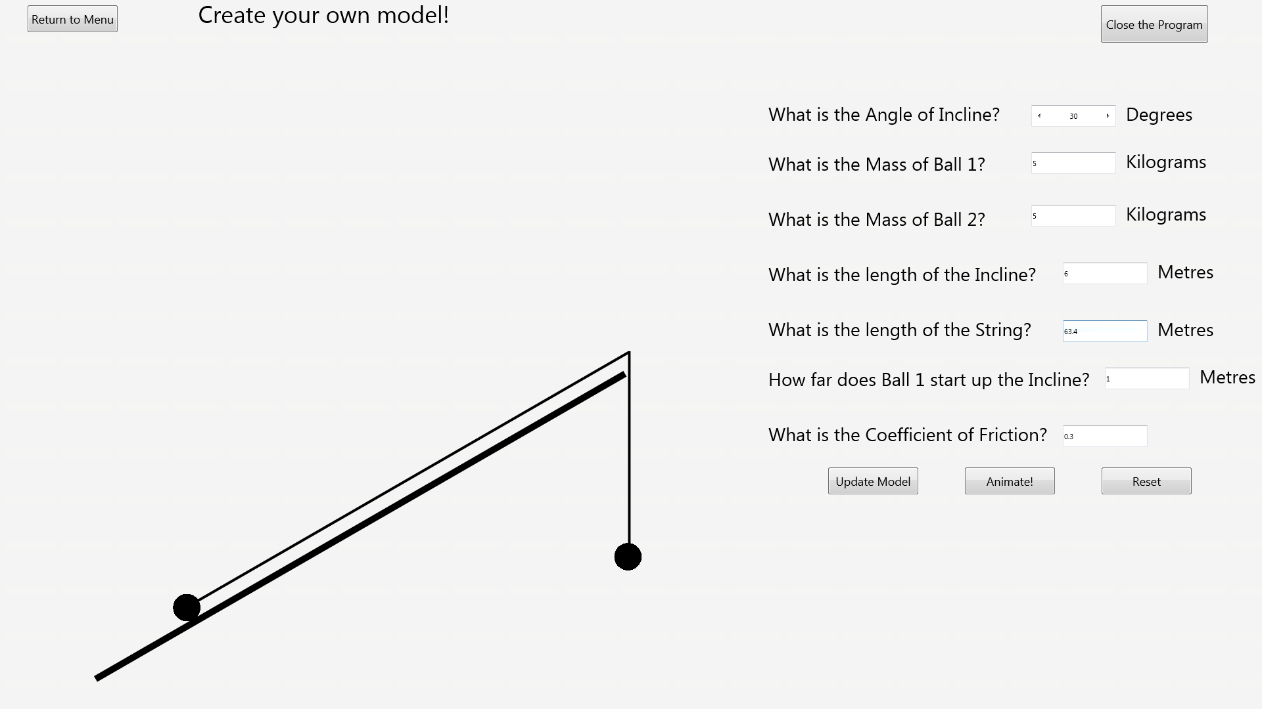After:

### Test 22

Before:

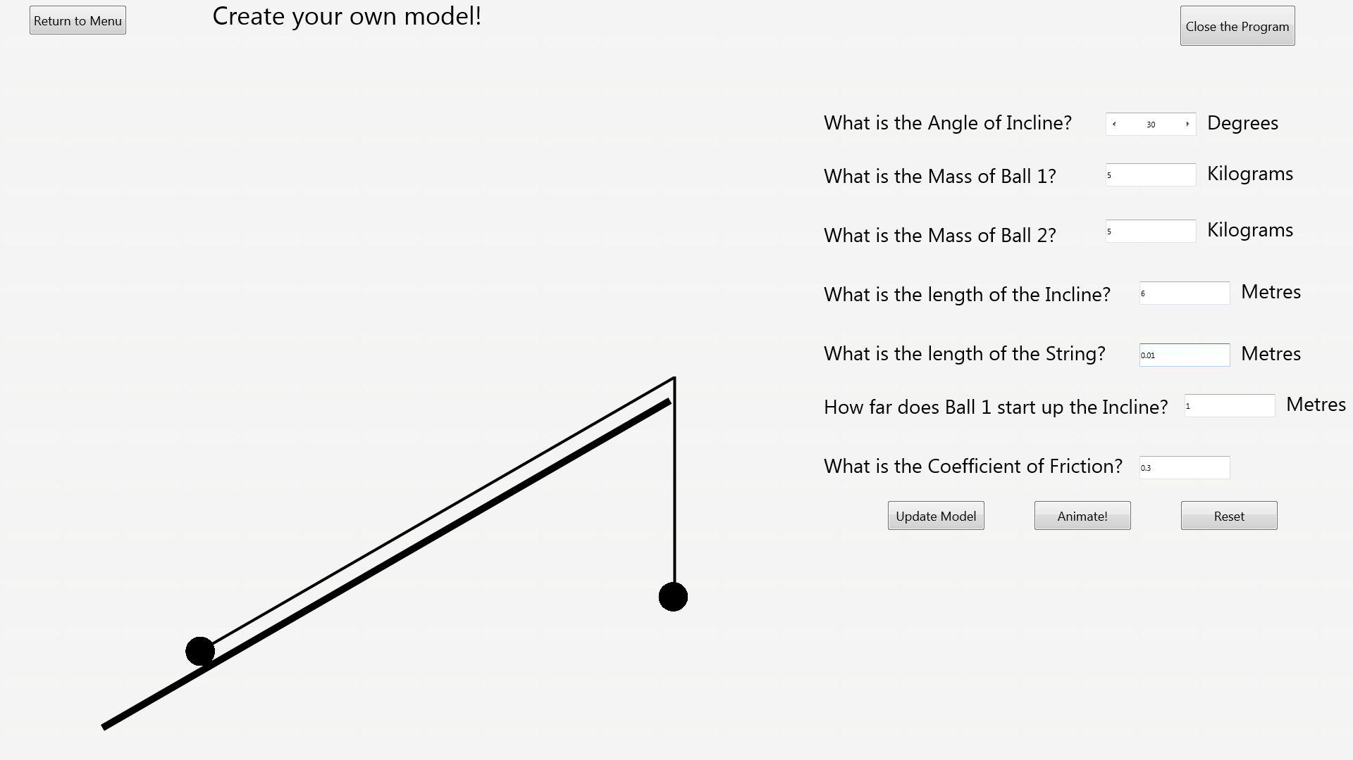After:

### Test 23

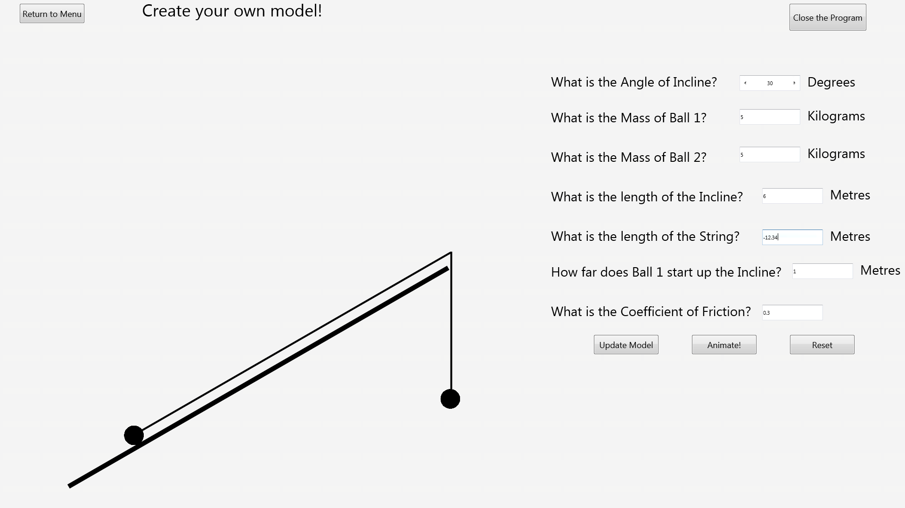Before:

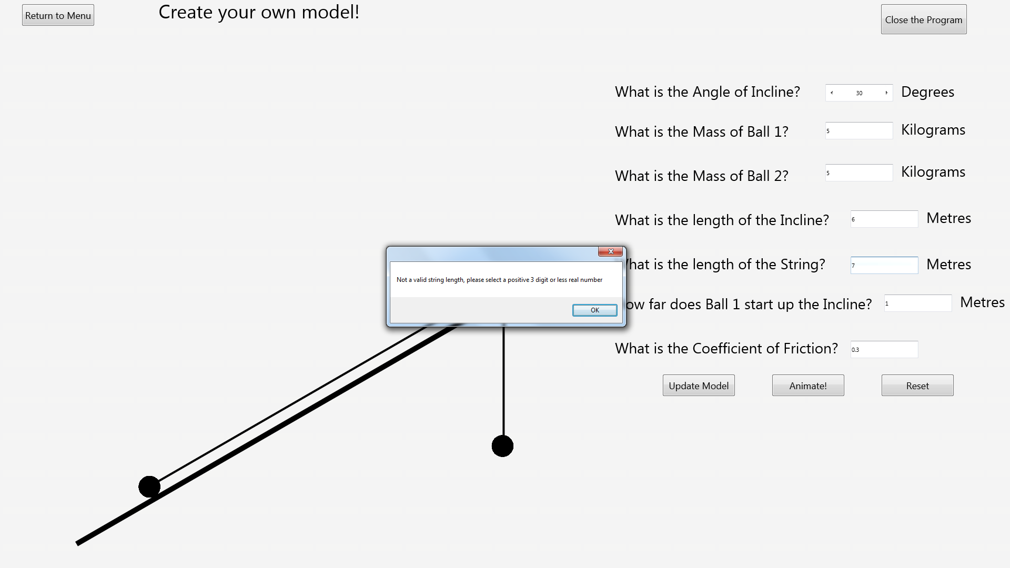After:

### Test 24

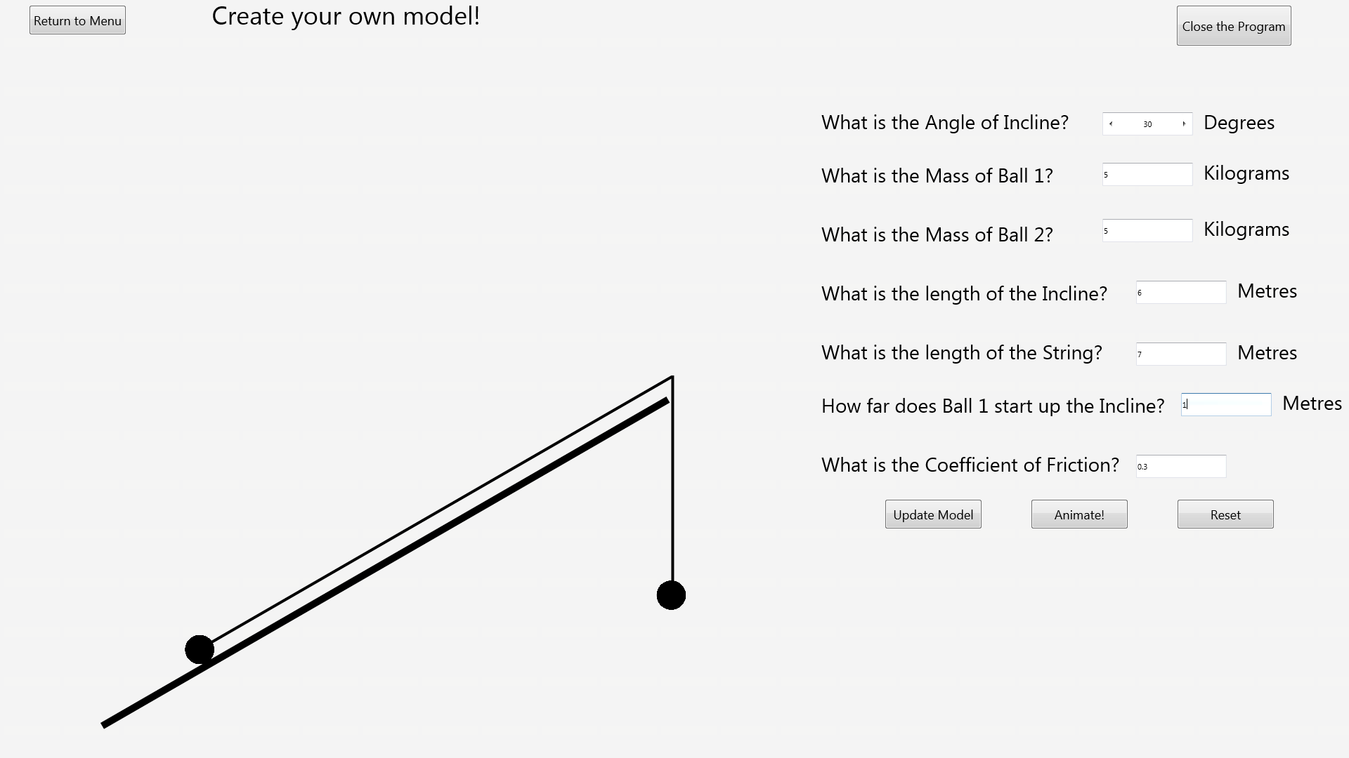Before:

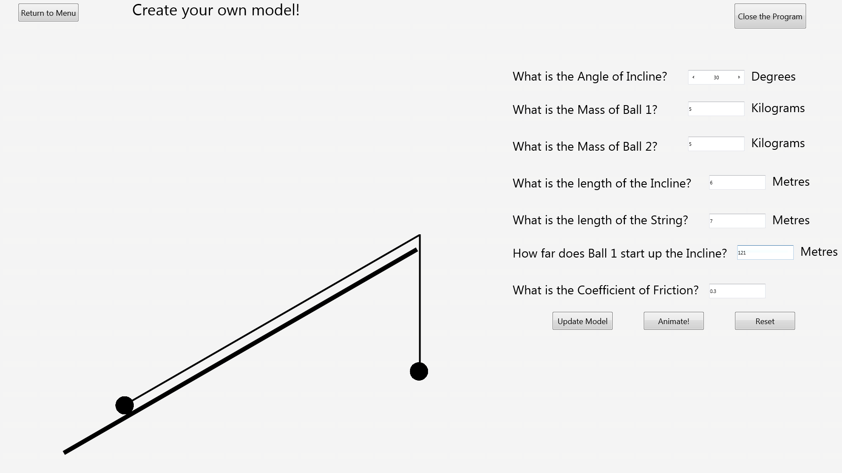After:

### Test 25

Before:

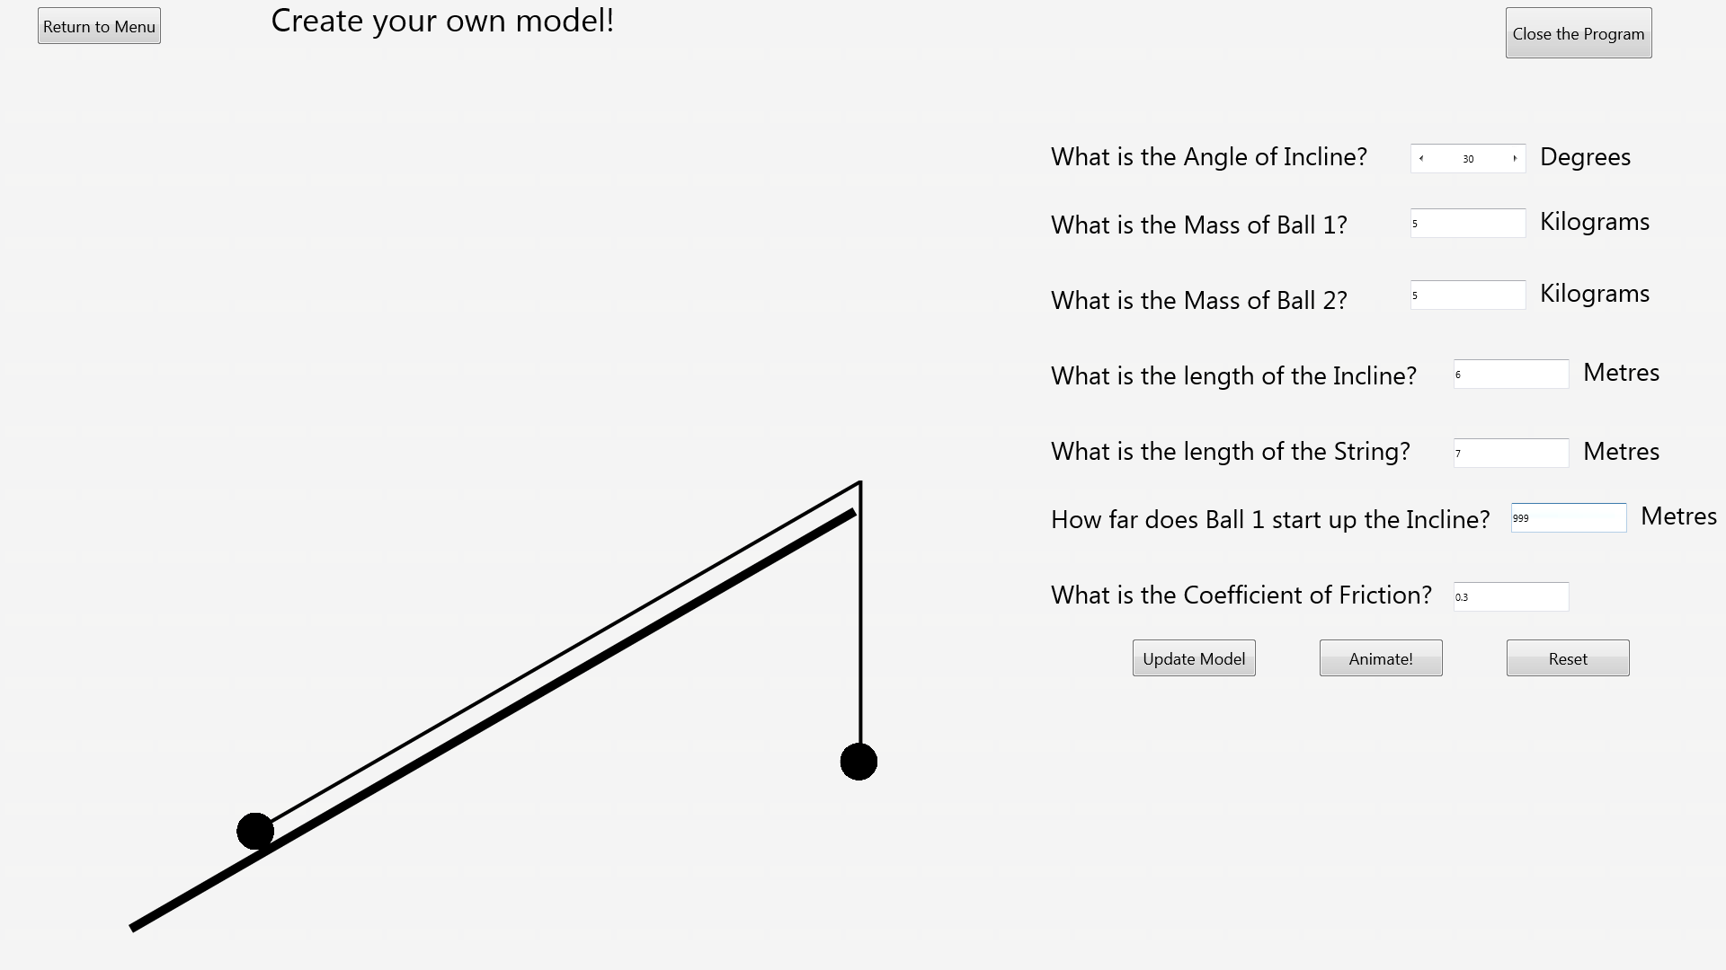After:

### Test 26

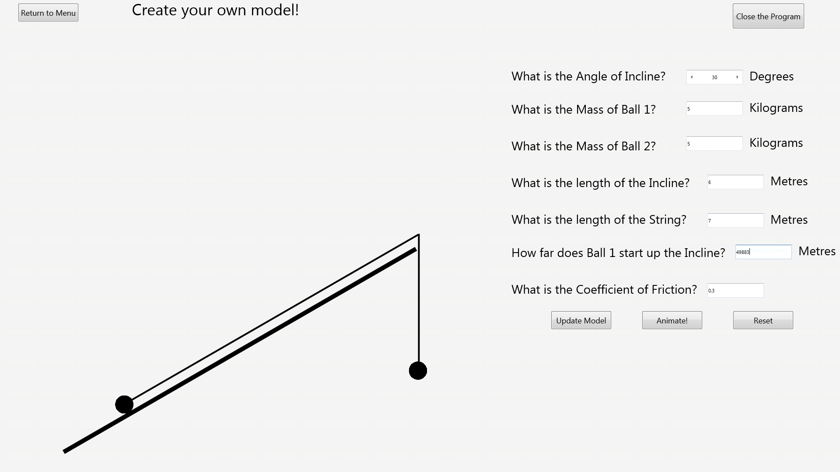Before:

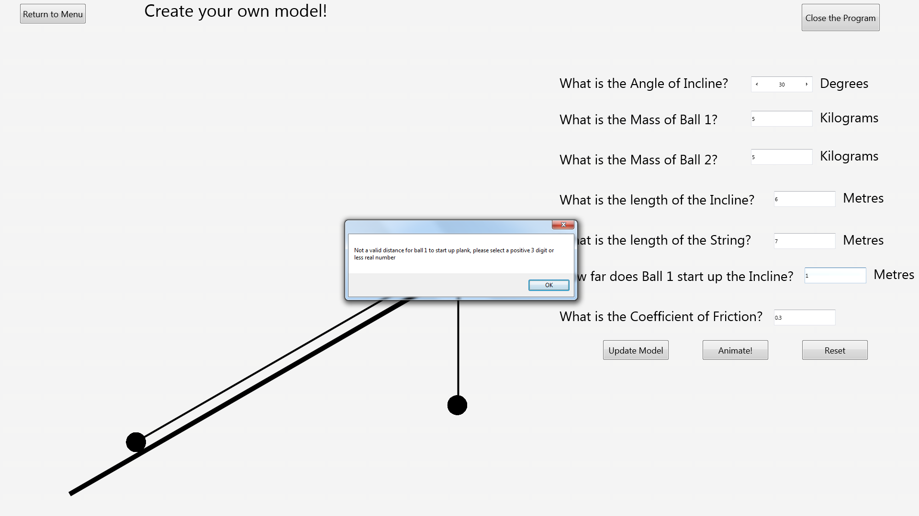After:

### Test 27

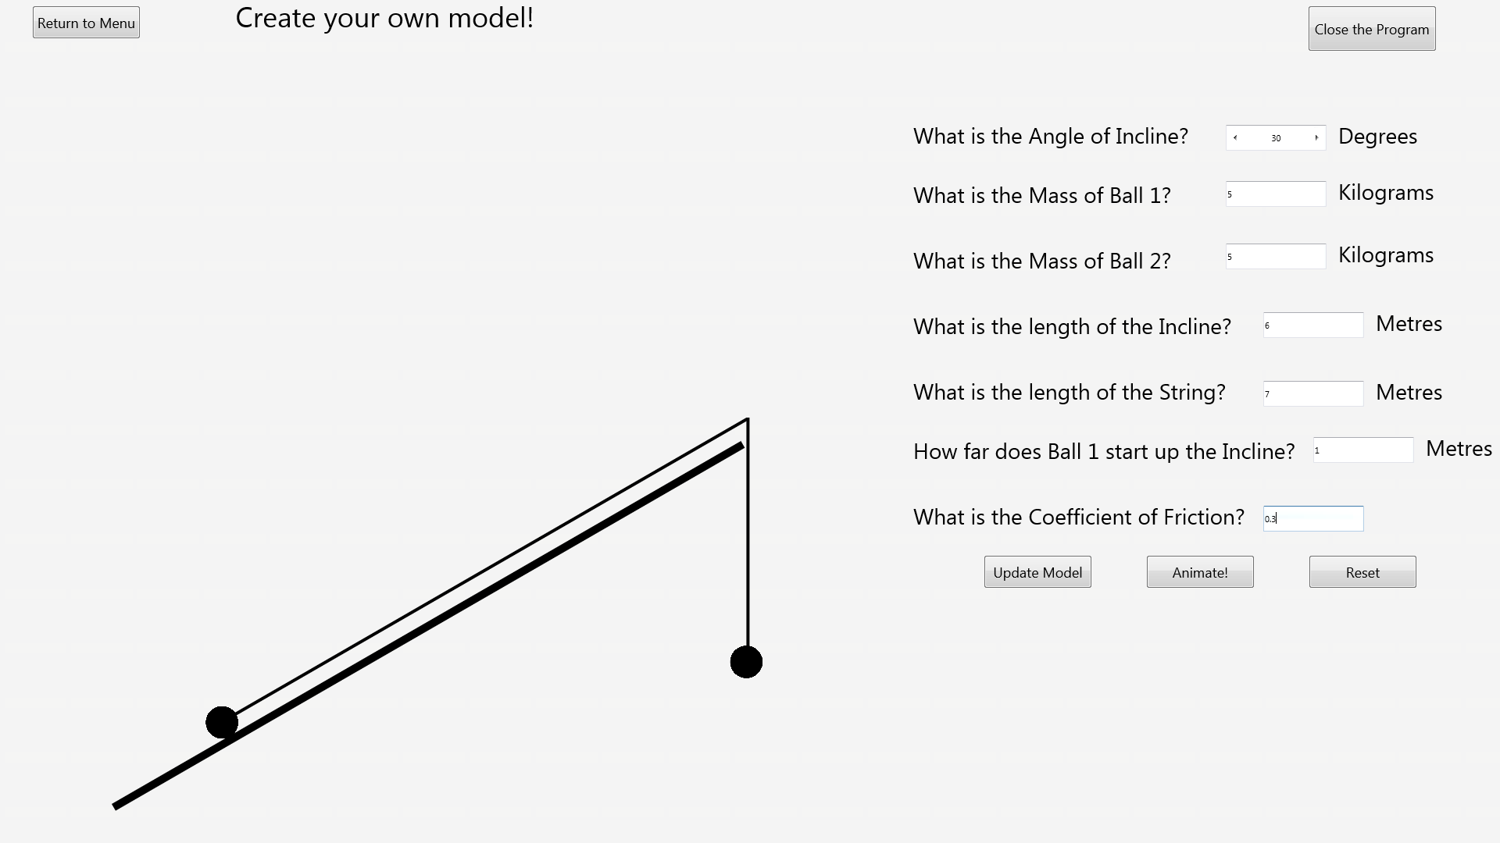Before:

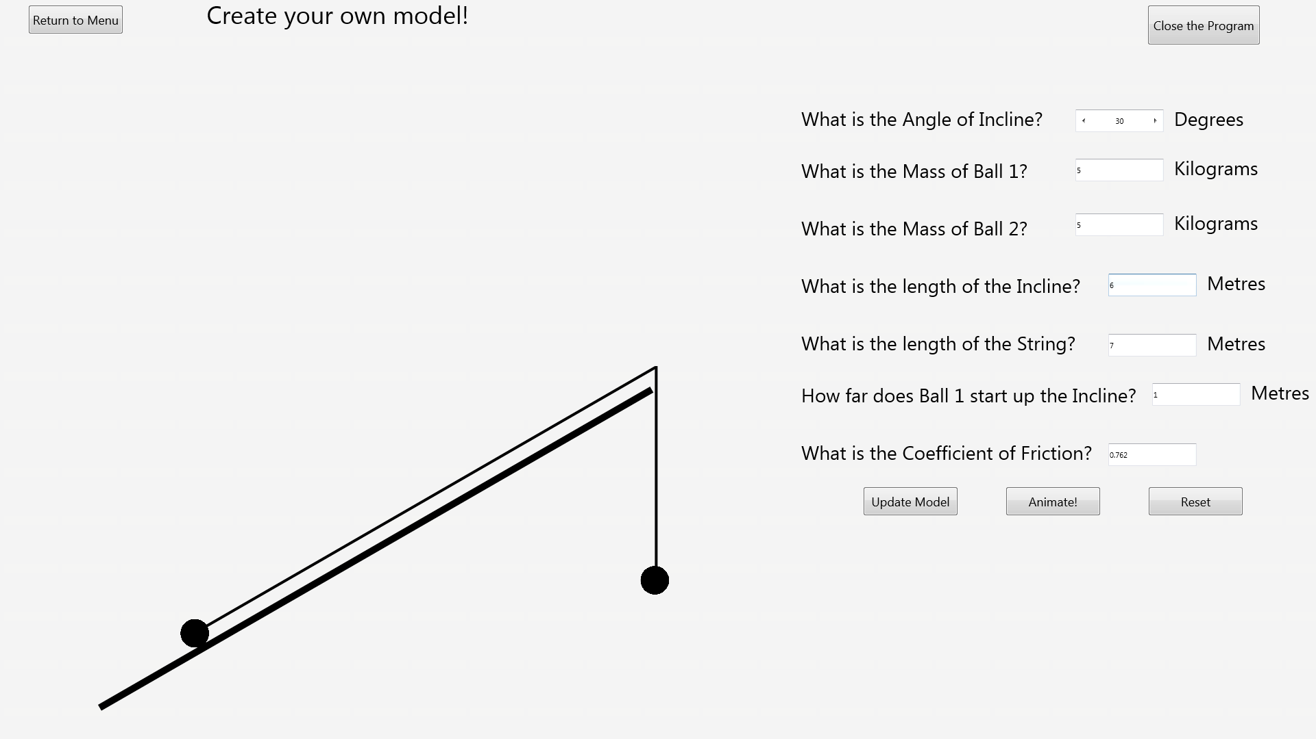After:

### Test 28

Before:

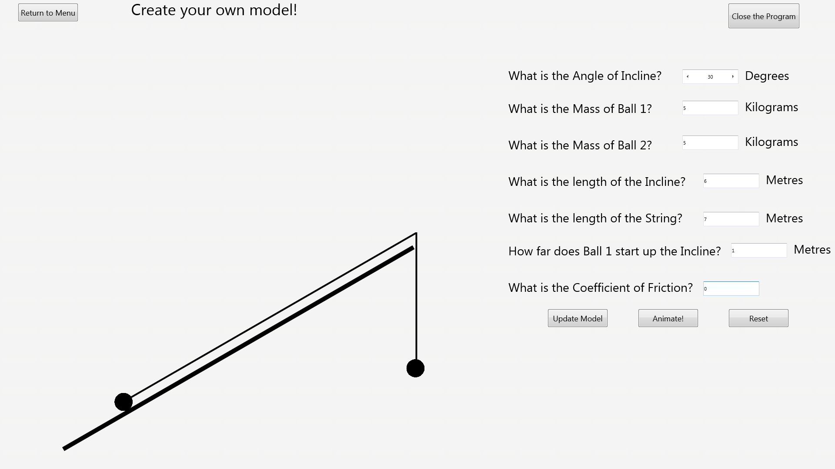After:

### Test 29

Before:

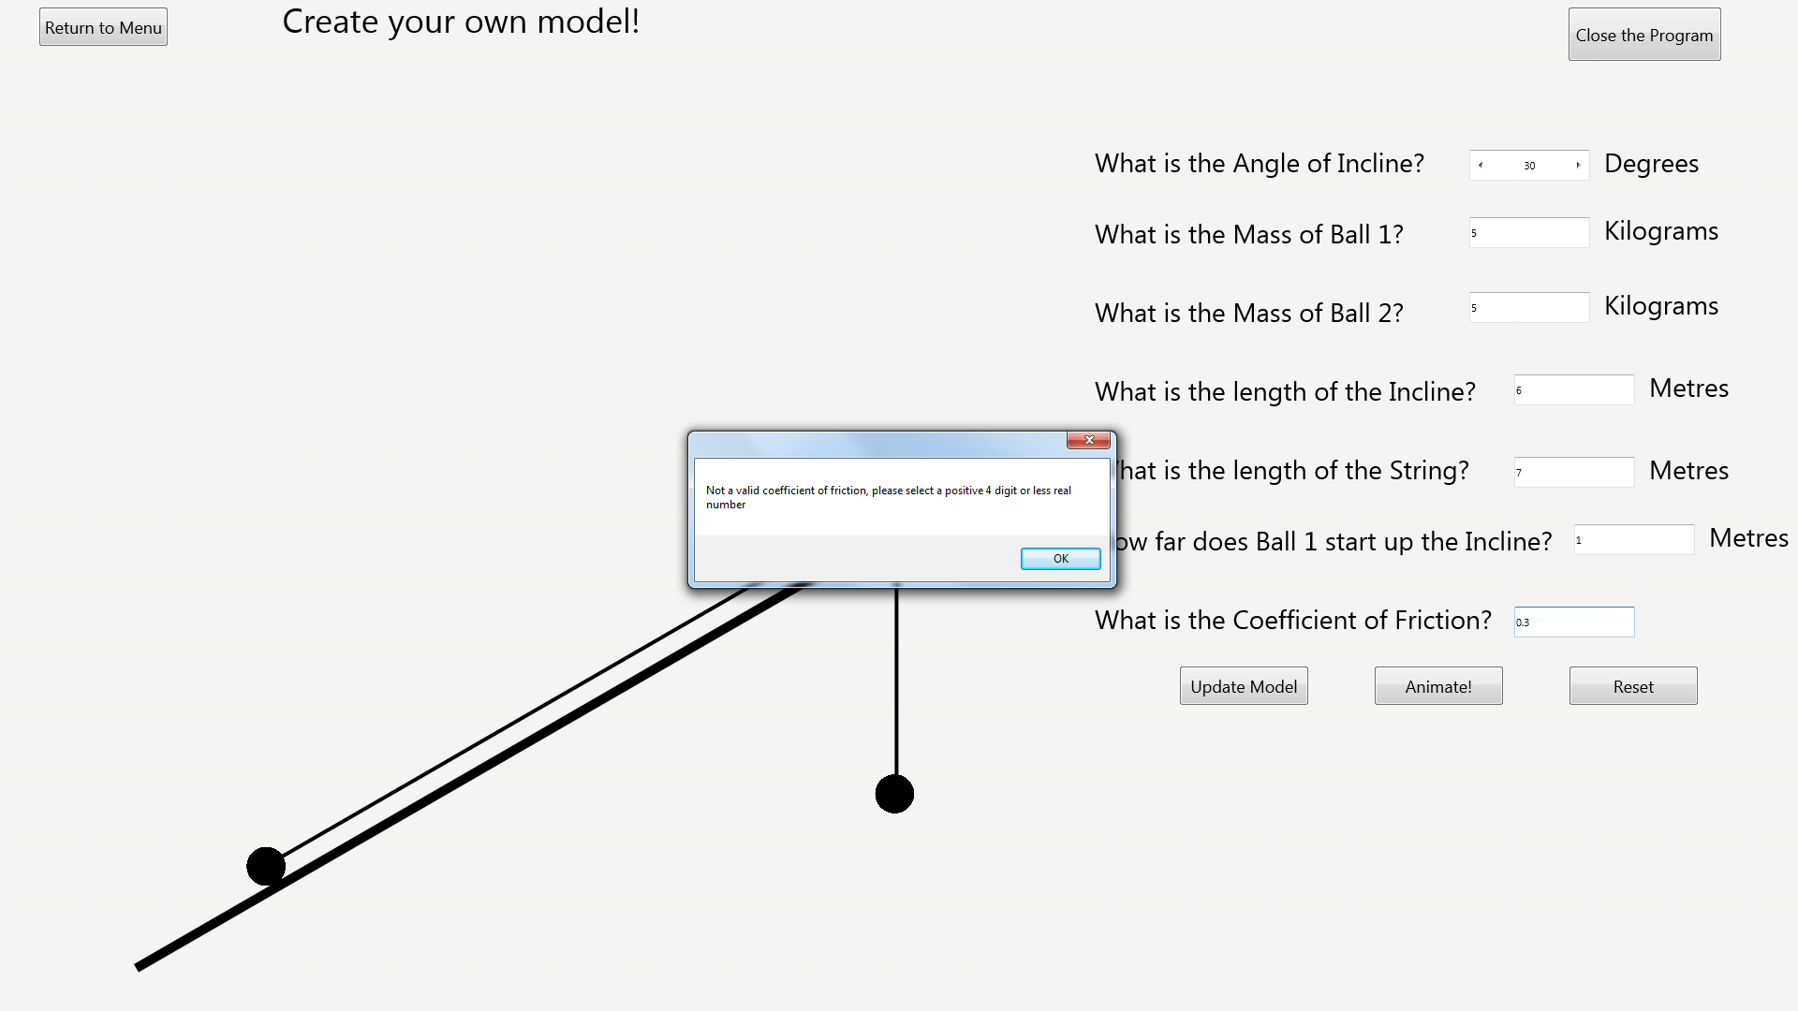After:

### Test 42

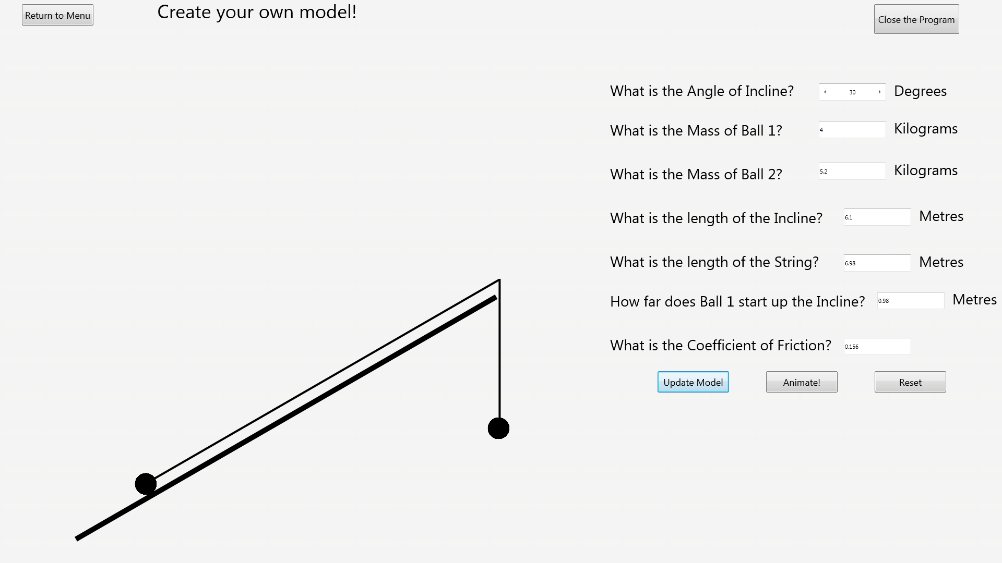Before:

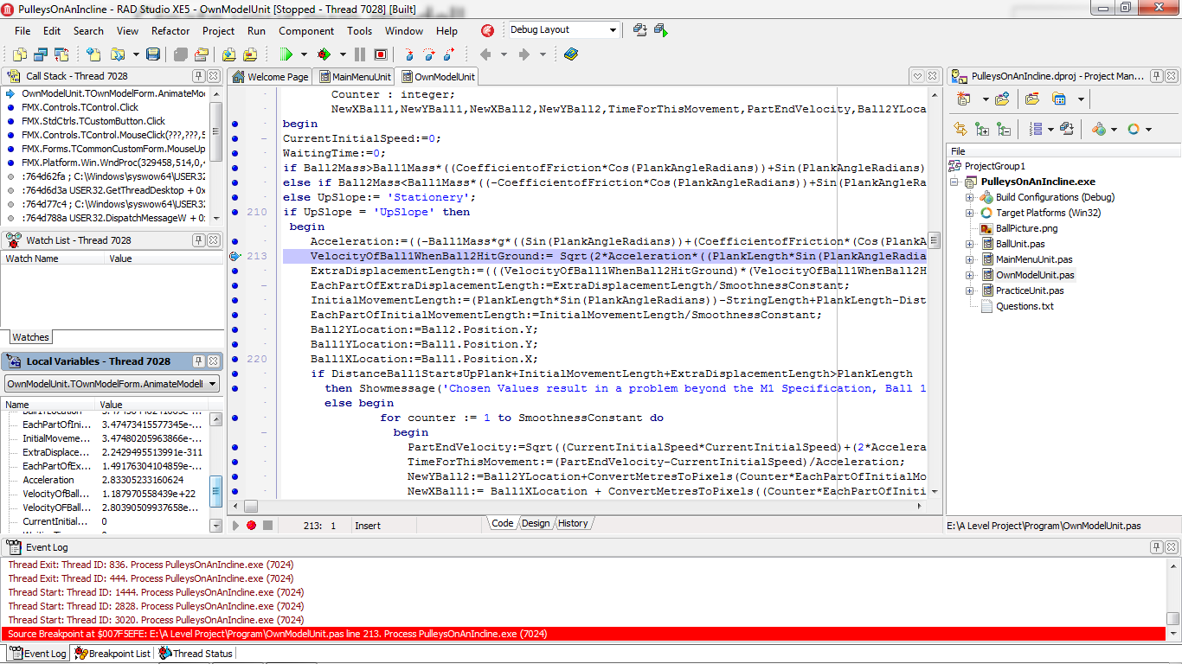After:

### Test 43

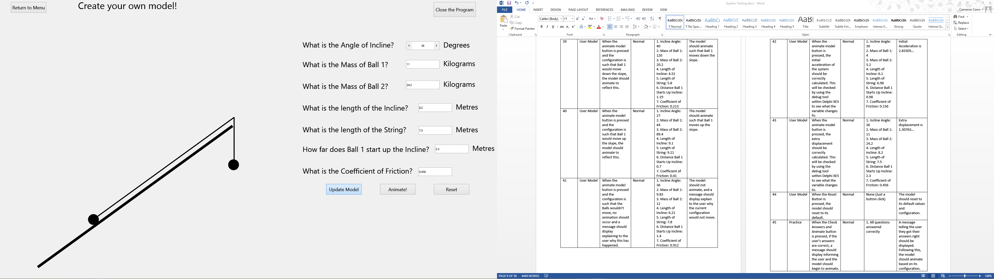Before:

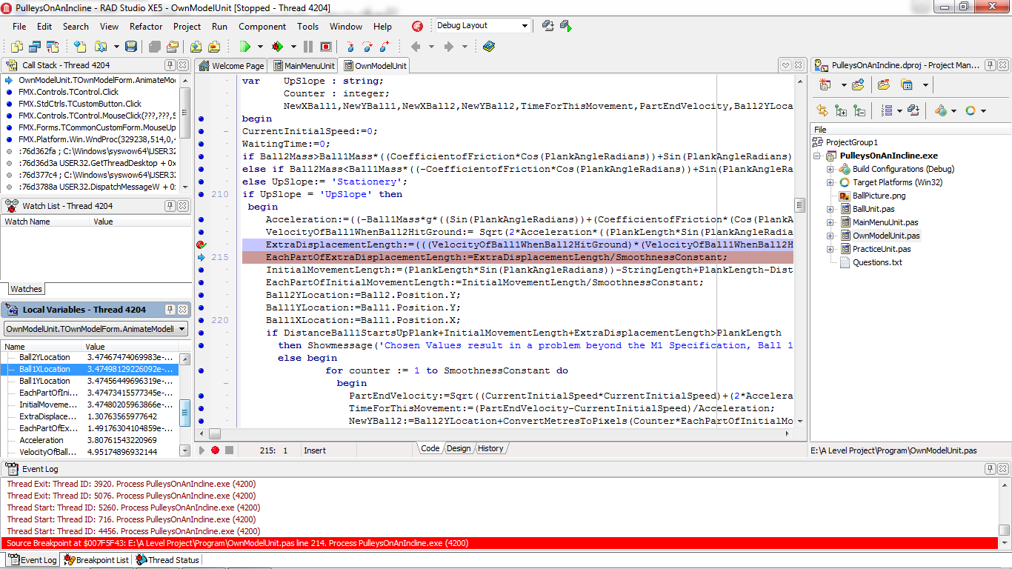After:

### Test 47

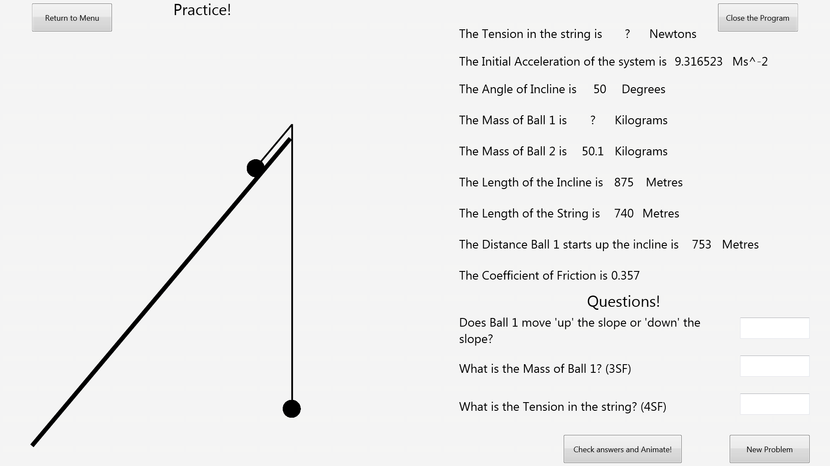Before:

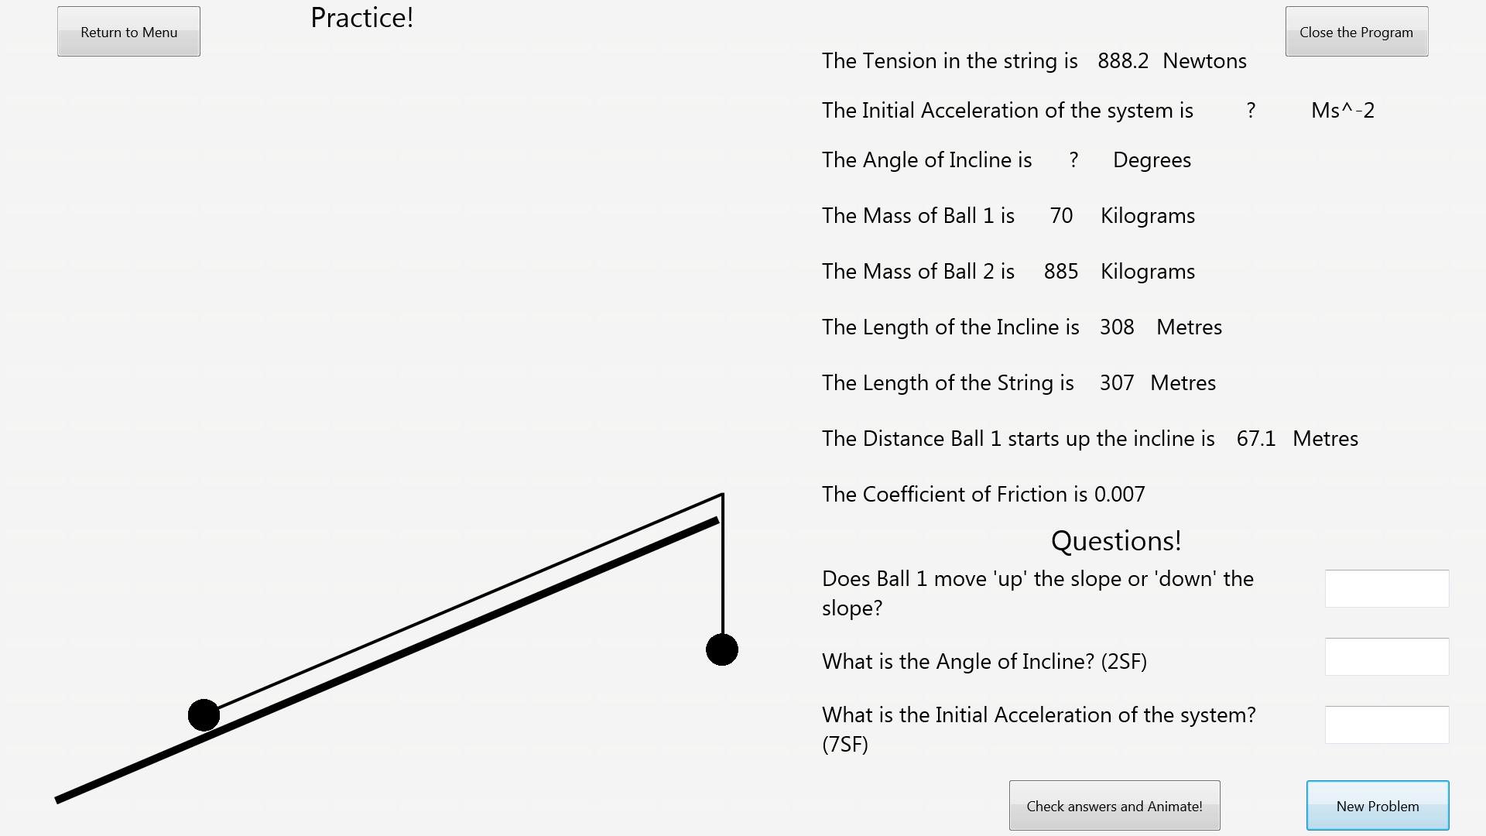After: